Department of Physics, Chemistry and Biology

Master Thesis

Foraging and exploratory behaviour in
Red Junglefowl (Gallus gallus) selected for
fear of humans

Emma Walett
LiTH-IFM- Ex--2306--SE

Supervisor: Per Jensen, Linköpings universitet
Examiner: Matthias Laska, Linköpings universitet


Department of Physics, Chemistry and Biology
Linköpings universitet
SE-581 83 Linköping, Sweden

Content

1 Abstract ............................................................................................................... 1
2 Introduction ......................................................................................................... 1
2.1 Domestication .......................................................................................... 1
2.2 Contrafreeloading .................................................................................... 2
2.3 Red Junglefowl (Gallus gallus) ............................................................... 3
2.4 Aim and Hypothesis ................................................................................. 4
3 Material and Methods ......................................................................................... 5
3.1 Animals .................................................................................................... 5
3.2 Housing conditions and management at Kruijt and Wood-Gush ........... 6
3.3 Selection .................................................................................................. 6
3.4 Foraging and exploratory test .................................................................... 6
3.4.1 Test arena ...................................................................................... 7
3.4.2 Experimental procedure ................................................................ 7
3.4.3 Data analysis and statistics for foraging and exploratory test ...... 8
3.5 Undisturbed behaviour test ....................................................................... 8
3.5.1 Data analysis and statistics for the undisturbed behaviour test ... 9
3.6 Open field test ......................................................................................... 9
3.6.1 Data analysis and statistics for the open field test ........................ 9
4 Results .................................................................................................................. 10
4.1 Correlation in foraging and explorative behaviour between
different ages (P0) .................................................................................... 10
4.2 Comparisons between the first generation (P0) and the
second generation (F1) ............................................................................. 13
4.3 Undisturbed behaviour test (P0) .............................................................. 17
4.4 Open field test (F1) .................................................................................. 20
5 Discussion ............................................................................................................ 22
5.1 Correlation in foraging and explorative behaviour between
different ages (P0) .................................................................................... 22
5.2 Comparisons between the first generation (P0) and the
second generation (F1) ............................................................................. 23
5.3 Undisturbed behaviour test (P0) ............................................................. 23
5.4 Open field test (F1) ................................................................................. 24
5.5 Conclusion ............................................................................................... 25
6 Acknowledgements ............................................................................................. 25
7 References ............................................................................................................ 26

1 Abstract

Domestication is a process in which animals become adapted to a life among humans by means of selection. A reduced fear of humans is probably one of the first aims of selection, intentionally or unintentionally. Animals that have undergone the process of domestication have a different appearance than animals in the wild (domestic phenotype) and behave in a different way towards humans. In this study I have looked at foraging and explorative behaviours in an unselected parental generation of red junglefowl and their offspring. The parental generation were bred in three lines, a high line, with birds displaying a strong fear of humans, an intermediate line, birds showing a modest fear, and one low line, with birds performing a more tame behaviour towards humans. I presented the birds with three different feeding alternatives, familiar chicken food, meal worms camouflaged with wood shavings and just wood shavings. I counted number of pecks in the different food options, number of changes between sites and how many sites a bird visited. The results show that females of both generations were more explorative than males, by pecking more in cups of meal worms hidden in wood shavings whereas the males pecked more in cups containing chicken food. Females also moved around more in the arena. Results from the first selected generation show significant differences between the selection lines among the females, with females from the high and low groups being the most explorative.

Keywords: Domestication, Open field test, Red Junglefowl (Gallus gallus), Selection effects

2 Introduction

2.1 Domestication
Domestication is defined as “that process by which a population of animals becomes adapted to man and to the captive environment by some combination of genetic changes occurring over generations and environmentally induced developmental events reoccurring during each generation” (Price, 1984, p. 3). Darwin contemplated the process during which variation appears and he put forward the notion that the changes were exclusively due to environmental influences and that the state of the parental organism during fertilization and the offspring’s embryonic development put down the base for the offspring’s characteristics (Trut et al. 2009). He also noted the effects arisen from inbreeding and crosses, and illustrated how quick variations can occur due to selected breeding (Trut et al. 2009).
1
1
This swiftness is illustrated by Belyaevs experiments on foxes in the 1960`s (Belyaev et al. 1984; Trut et al. 2009). During this experiment breeding pairs of farmed foxes were selected based on their reaction towards humans, animals selected displayed no aggression towards people or tried to avoid them. Later generations were selected purely on their “tameability” as pups and by the 30th generation almost 50 % of the foxes displayed a very doglike behavior (tail wagging and whimpering sounds) towards even unknown humans (Trut et al. 2009). These extraordinarily human friendly foxes also displayed changes in their breeding patterns and morphological changes, like floppy ears, white markings on the forehead and curly tails (Trut et al. 2009). Furthermore, this kind of physical and behavioural changes has been noted in other species during domestication experiments, for example rats (Albert et al. 2008) and sheep (Lankin, 1997), and could be referred to as being typical for a “domesticated phenotype” (Jensen, 2006).
Jensen (2006) identified a number of typical domestication changes that can be observed in animals undergoing the process of domestication. External morphological changes such as alterations in fur and colouration (longer fur and increased frequency of white or spotted individuals) can be observed in domesticated livestock. In the early stages of domestication animals normally have a reduced body size compared to wild counterparts, but at the end stages animals in captivity could be either much larger or much smaller than the original wild animal. An example of this is the Shire horse and the Falabella (Zeuner, 1963). A change in relative size of body parts is also common, including brachycephaly (shortening of the skull) and chondrodystrophy (the shortening of legs) (Zeuner, 1963; Clutton-Brock, 1999). Internal morphological differences such as a decrease in brain size in proportion of the body and accumulation of fat under the skin (Clutton-Brock, 1999) and in certain rather unusual parts of the animal’s body (for example the fat-tailed sheep) can also be observed as an effect of domestication (Zeuner, 1963). Developmental changes, like earlier sexual maturity and changes in the length of sensitive periods for socialisation have been reported by Belayaev and colleagues (1984). The process of domestication is also associated with behavioural differences, such as increased sociability and a reduced fear of humans (Price, 1984). The correlated responses must logically be a consequence of either pleiotropic genes or linked genes, probably affecting many different genetical pathways and resulting in effects on gene expression.
Price (1984) identifies three key mechanisms that influence gene frequencies of animals in captivity: artificial selection, natural selection in captivity and relaxed natural selection. Artificial selection is a selection based on traits that are desired by humans, for example productivity, making it a goal-oriented selection. During the process of domestication, people have probably preferred to breed animals that are easy to handle and that cope well with the captive environment. Individuals that demonstrate extreme aggression or extreme fear towards humans are probably discarded from the breeding stock before they have a chance to mate. Man not only controls which animals get a chance to mate but also how many offspring an animal gets (Price, 1984). It is possible that selecting for a preferable trait can result in a not deliberate selection for other traits the ones selected for in the first place. The second mechanism acknowledged by Price (1984) is the process of natural selection in captivity. This selection operates on eliminating individuals that are unable to mate and/or produce offspring during captive conditions, leading to animals adapted to that particular captive environment. Humans are not actively involved in this process, since the animals can chose mating partners themselves within the group, but is still limiting an animal’s choices. The relaxed natural selection acts by favouring traits that should be selected against in the wild (Price, 1984). During captivity humans serve as givers, providing the animal with food, shelter and healthcare, preserving genes that might have been eliminated in the wild. In the wild, animals spend a large part of their day searching for food and water (Price, 1984; 1999), forcing them to make an active choice of what to feed on and where, whereas animals in captivity are provided with food and water, often at one place, thereby limiting their opportunity to make a choice. This provision of food for animals in captivity has led to a relaxation of natural selection on behaviour associated with food choice, for example the ability to find food and the motivation to explore and investigate new environments (Price, 1999).

2.2 Contrafreeloading
The expression contrafreeloading is used for the feeding behaviour in which an animal chooses to work for food even though identical food can be acquired with less exertion at a site nearby. This phenomenon is normally studied by offering an animal two food choices, one freely available (i.e. less energy demanding) and one with identical food that demands an effort of the animal (i.e. more energy demanding) (Osborne, 1977; Lindqvist, 2008). The “work” can for instance involve pressing a lever, move around in mazes, jump over obstacles or perform a more active foraging behaviour, like search for food in sawdust or straw (Neuringer, 1969; Forkman, 1991; Gustafsson et al. 1999; de Jonge et al, 2008).
2
This phenomenon has been shown in a number of species, for example in Mongolian gerbils (Meriones unguiculatus) (Forkman, 1991), domestic fowl (Gallus gallus domesticus) (Duncan and Hughes, 1972; Lindqvist, 2008; Lindqvist et al. 2009), mice (Mus musculus), chimpanzees (Pan troglodytes) and humans (Homo sapiens) (reviewed by Ingles et al. 1997). Contrafreeloading can be explained from a functional perspective, because it gives the animal a chance to gather information about alternative food sources in its environment (Inglis et al. 1997, Bean et al. 1999). Animals in the wild always run the risk of food shortages due to natural factors such as drought and fires. One strategy to avoid the likelihood of starvation is to gather information about alternative food sources, which might still be available later (Lindqvist et al. 2002).
The amount of contrafreeloading an animal performs can decrease due to some environmental factors, for example a period of food deprivation, increased demands in order to get the food or a high degree of uncertainty in the environment (Forkman, 1991; Inglis et al. 1997). Additionally, Schütz and Jensen (2001) compared the degree of contrafreeloading in Junglefowl, Swedish bantam and White Leghorn layers and concluded that Jungle fowls and bantam perform more contrafreeloading than White Leghorn layers that have been heavily bred on productive traits, thereby putting forward the notion that domestication influences contrafreeloading as well.

2.3 Red Junglefowl (Gallus gallus)
The Red Junglefowl (Gallus gallus) is considered to be the ancestor of all modern poultry and the domestication occurred at least 8000 years ago in Southeast Asia. From Southeast Asia chickens were taken north to become established in China about 6000 BC. Chickens spread throughout Europe during the Iron age, 700 BC (West and Zhou, 1989; Fumihito et al. 1994). Wild Red Junglefowl can still be found in Southeast Asia (India, China, Java, Malaysia, Indonesia and the Philippine (Al-Nasser et al. 2007)) and small populations are kept in zoos and at bird collectors all over the world (Kaul et al. 2004; Håkansson, 2007). The natural habitat of the Red Junglefowl is variable and the birds use most types of forests in Southeast Asia, but can also be found near cultivated areas (Håkansson, 2007).
Male and female Red Junglefowl show strong sexual dimorphism (see Fig. 1 and 2) and live in territorial groups with one dominant male, one or several females and their offspring (Håkansson, 2007). The hens are of a rather dreary and cryptic coloration, where yellow, brown and gray are the predominating colours, whereas the males are more colourful, with a combination of gold, red, brown, orange feathers on the body and metallic green and blue shades of the dark tail feathers with a white downy puff at the base of the tail (Collias and Collias, 1967; Collias and Saichuae, 1967) (Fig. 1 and 2).

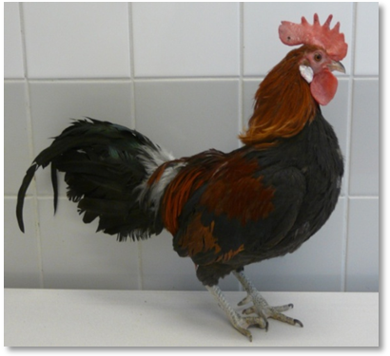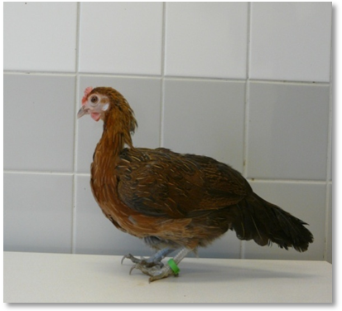

Figure 1. RJF male Figure 2. RJF female (photos Maria Ericsson)

Red Junglefowl are seasonal breeders (March through June) (Collias and Collias, 1967; 1996) and hens leave the group in order to nest, incubate the eggs and raise their broods. Other behaviours such as rest, dust bathing and foraging are synchronised. Foraging behaviour follows a diurnal rhythm with a peak in food intake early in the morning and one before dark (Collias and Collias, 1967; Savory, 1980). However, studies show that Red Junglefowl in captivity spend most of their active time, 90 %, performing foraging behaviours (Dawkins, 1989). When foraging, the animals scratch the ground with their feet, exposing edible items, then take a step backwards and then peck at and eat the edible item (Lindqvist, 2008). In the wild, chickens are omnivorous and their diet consists of a mixture of fruit, seeds, herbage, different kinds of insects as well as snails, worms and lizards (Collias and Collias, 1967; Collias and Saichuae, 1967).
Behaviour studies of Red Junglefowl and a strain of laying hens point to some difference in their foraging and exploratory behaviour (Schütz and Jensen, 2001; Schütz et al. 2001). The layers were more inactive than the junglefowl, showing a more reduced foraging and exploratory behaviour and are less inclined to explore unknown food sources. Another study showed that Red Junglefowl were generally more explorative and able to adapt better to a sudden change in environmental conditions than laying hens (Lindqvist et al. 2002).

2.4 Aim and Hypothesis
The aim of this project was to develop a foraging and exploratory test and study foraging and exploratory behaviours in two generations of Red Junglefowl, the P0 generation and the first selected offspring generation, F1. The selection was based on the P0`s reaction towards humans (fear response). Based on previous studies, comparisons between Red Junglefowl and White Leghorn, I hypothesise that selection for reduced fear of humans will simultaneously increase the number of pecks in the easily accessible and familiar food (standard chicken food) and decrease the amount of exploratory behaviour (changes between boxes and pecks cups with wood shavings).

3 Materials and methods

3.1 Animals
In this study I used two generations of Red Junglefowl, P0, 75 birds, 33 roosters and 42 hens and their first selected generations of offspring’s, F1, 105 birds, 57 roosters and 48 hens. Both generations were first tested in the foraging/exploratory test at the same age, 13 weeks. The original generation of the birds I used in this experiment (P00) were a cross between two different populations of Red Junglefowl, one from Götala research station (Got) and one from Copenhagen Zoo (Cop). Eggs were brought from Götala and Copenhagen Zoo, to the animal facility at Linköpings University and hatched here to create the parents for the P00 generation. The two populations have been crossed to maximise the out breeding so all birds have lineages from both populations, as shown below (Fig. 3).

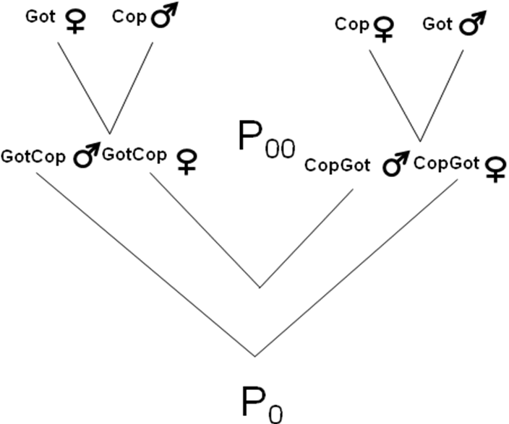
Table 1. Pedigree over the parental crosses

The population from Götala originated from birds at Frösö Zoo, which were originally wild caught in Southeast Asia. Götala research station got the birds from Frösö Zoo in 1993 and they have been kept at the research station since then. The birds were kept indoors in pens, about 20 birds on 3 x 3 m, and every now and then had access to outdoor pens the same size. Because of other research projects the birds were used to being handled by humans. At the research station the animals had access to commercial chicken food and water ad libitum (Håkanson and Jensen, 2005; Håkanson et al. 2007).
The population from Copenhagen zoo lived under semi natural conditions, roaming freely over the total area of the zoo, about seven hectares. These birds originated from birds brought in from the wild population in Southeast Asia, during the 1950´s. The zoo population has been subjected to infrequent predation, by for example foxes and birds of prey, during the time spent in captivity. The birds were provided with a feeding site, completed with commercial chicken food, fruits and seeds. In addition to this feeding site the birds were able to search for food in other places (Håkanson and Jensen, 2005; Håkanson et al. 2007). Birds from these populations have been used in previous behavioural studies, for example in an exploratory behaviour test. In this study the researchers did not find any significant differences in exploratory behaviour between the two populations (Håkanson et al. 2007).

3.2 Housing conditions and management at Kruijt and Wood-Gush
All individuals used in these experiments were hatched in incubators and kept together in pens in the hatchery (Kruijt) before they were moved to the animal facility and research lab at Vreta (Wood-Gush) at the age of approximately five to six weeks. At hatching, the chicks were marked with wing tags with a unique code number, vaccinated against Marek`s disease and weighed. A second weight was taken at one week of age. When the chickens were newly hatched their pens in the hatchery were furnished with wood shavings on the floor, hanging water containers and a plate for food on the floor directly under a heat lamp. After some weeks hanging food containers were placed in the pen and the plate on the floor was removed. The pens were 0.98 m² (1.4 m X 0.7 m). The temperature in the hatchery was kept at 25ºC and the light was kept at a 12:12 hour light: dark cycle. At the age of three weeks the chicks were tested in an open field test (further details in section 3.6) and a social reinstatement test. When the animals did come of age and were moved to Vreta they were first placed in a 7.5 m² pen, furnished with wood shavings on the floor, hanging food and water containers and a perch. The birds stayed in this pen for some weeks until they had matured enough to be separated based on sex. When the birds were sex separated they were placed into a third pen in which they stayed for the remainder of their life. This pen (referred to as their home pen) was 7.75 m² (3.1 m X 2.5 m) with a ceiling height of 3.0 m. The home pen contained food and water ad libitum, nest boxes, perch and wood shavings on the floor. The original light: dark cycle of 12:12 was maintained and the temperature was kept at 19ºC. The two pens were situated next to each other, separated by a wall of wire-mesh, so the birds had full visual, auditory and even some tactile contact between them.

3.3 Selection
Prior to my foraging/exploratory test the birds had been subjected to a fear of humans test in order to assess fear responses and create a selection value based on their reaction towards humans. The young chickens were taken, one at a time, from their home pen and placed in a rectangular arena made up of wooden panels. A human entered the arena and moved towards the bird and finally tried to grab it. The chicken´s fear reaction was scored from one to three, with one given to birds displaying a tame behaviour and three given to birds that are most afraid and displayed “untame” behaviours (Jöngren and Jensen, unpublished data). Based on these tests, 20 birds (10 hens and 10 roosters) that displayed a high degree of fearful behaviours and 20 birds that displayed a more unafraid, “tame”, behaviour towards people were selected as founders of a high line and a low line. In addition to these two extremes, 20 intermediate birds were also chosen as founders of a new line. The breeding couples were designed to maximize the out breeding within the lines and include as many families as possible. The offspring, F1, underwent identical behavioural tests as the parental generation to determine a selection score, before they, too, were tested in the same foraging and exploration test.

3.4 Foraging and exploration test
This test was designed in order to see if birds from different selection lines had different food preferences. Birds were given a choice of three different food options in four different sites and the numbers of pecks in the different options were counted. The number of sites a bird visited, the number of cups it fed from and the number of changes between food sites were also noted. All measurements were used to assess the birds foraging and exploratory behaviour.
3.4.1 Test arena
The arena for the foraging/exploration test consisted of two squares, the inner square 0, 9 m² (the white area), and the outer one 2, 7 m² (the blue area) (fig. 4), made up of wooden panels. The floor of the outer square was dusted with wood shavings, while the inner square was brushed before the test period started and between every bird, in order to minimize pecks on the floor. Four cardboard boxes (1-4) were taped to the floor and three plastic cups were placed into each of them (Fig. 5). In each of the boxes I placed one cup with wood shavings and 20 mealworms, one cup with familiar chicken food and one cup containing just wood shavings. The mealworms were put in the middle of the cup with wood shavings all around them so no bird saw them at the beginning of their test trial. To the birds two cups appeared to have wood shavings and one chicken food. The different cups were changed in a randomized order between each chicken.

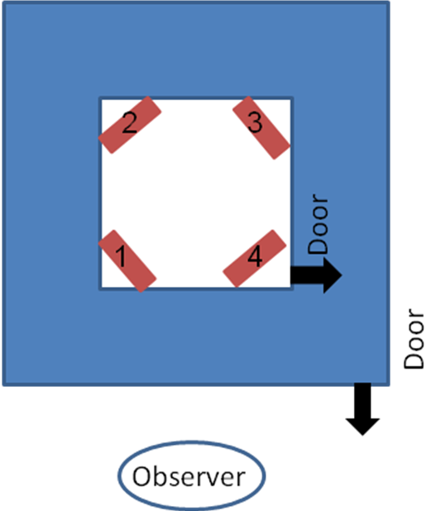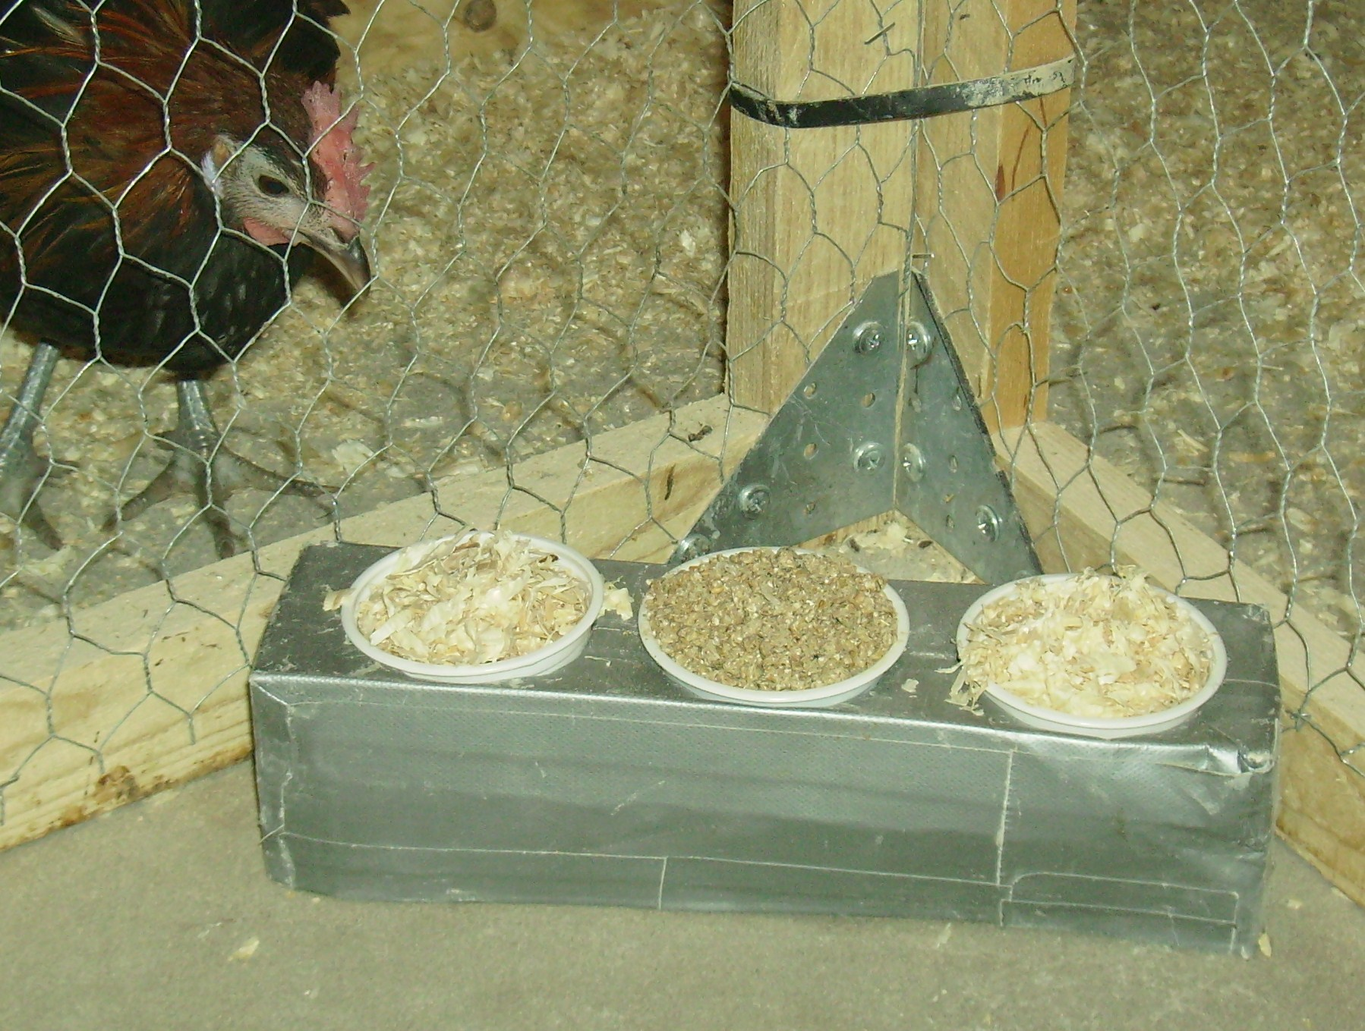

Figure 3, arena for the foraging/exploration test Figure. 4, box with different food options (mealworms, chicken food and wood shavings)

3.4.2 Experimental procedure
The parental generation (P0) was tested at the age of 13 weeks (May-June 2009) and then again at the age of 26 weeks (August- September 2009) and the first selected generation (F1) was tested at the age of 13 weeks (February 2010). When the test began the birds had been sex separated for some time and where kept that way during all tests. Some days before the onset of the first foraging/exploration test the birds had been subjected to a behavioural test measuring fear responses and a test to study social behaviour using mirrors. The birds had also been exposed to the cardboard boxes and the white plastic mugs in their home pens during the week prior to the test. An hour before the beginning of the test a group of five birds, were taken from their home pen and put into a holding pen where they were deprived of food. After the food deprivation all five birds were placed into the outer square of the test arena for ten minutes, in order to get the birds familiarised with the arena. After the habituation time one bird at a time was placed into the inner part of the arena and for five minutes the number of pecks at each of the three food options were recorded as well as the number of changes between boxes. Following the five minute test period, the focal animal was placed in the outer part of the arena and the inner square was cleaned, cups rotated before the onset of another trial.

3.4.3 Data analysis and statistics for the foraging/exploratory test
Foraging behaviour: the number of pecks in the different food sources, calculated as a percentage of the total number of pecks for each bird.
Exploratory behaviour: the number of changes between food boxes and the number of boxes and food cups explored.
After transformation the variables were analysed with analysis of variance (ANOVA). Correlation analyses were performed on test results from the different ages (13 and 26 weeks) in the parental generation. For the different variables the following comparisons were made: differences between hens and roosters and differences between the three selection lines.

3.5 Undisturbed behaviour test
In order to investigate whether the time budget differed between the selection groups we preformed an undisturbed behaviour test. In September 2009, after the second round of tests in the foraging/exploration test, when the birds of the P0 generation had reached the age of 27 weeks, they were placed into groups of ten then positioned into a familiar box (2.5 X 3 m), where we observed behaviours preformed during undisturbed conditions. This general behaviour test was performed in order to quantify other aspects of the foraging behaviour which may be correlated to the selection test results and to make an estimate of the bird’s time budget during the course of a day. The groups were placed into the pen in the afternoon and then left undisturbed until the next morning. All groups were tested for two hours in the morning and for two hours in the afternoon. Focal animal sampling was used according to a rotating plan. Each bird was observed for five minutes every hour, making it a total of 20 minutes of observation time per bird. The record method used was 1/0 sampling. The behaviours observed are listed in the ethogram shown below. During analysis, the behaviours were put together into the six categories displayed in bold letters in the ethogram.

Table 2. Ethogram for the undisturbed behaviour tests

Foraging and exploratory behaviours
Feeding/Drinking | Eating from food container/ Drinking from water bell
Explore ground | Walking or standing with head close to the ground, eyes focusing on ground items, peck at items, scratching at ground
Explore object | Peck at object, eyes focusing on object, uses beak or foot to manipulate object
Active
Walk | Two or more steps in any direction
Run | Two or more steps in considerable faster tempo than walking
Stand | Stands (legs erect) with open eyes, attending to the surrounding
Inactive
Lying down | Lying on the ground, no other movements
Sleep | Stand or sit with eyes closed, neck short, no head movements
Perch | Sits in any position on a perch
Comfort
Dust bathe | Vertical wing shake, and rubbing phase
Preen | Uses beak to trim and arrange feathers
Jump/flight | Flying or jumping exaggerated against wall or fence or up onto an object

3.5.1 Data analysis and statistics for the undisturbed behaviour test
Undisturbed behaviour test: time budget, expressed as the proportion of all sample intervals during which the behaviour has occurred.
After transformation all variables were analysed with analysis of variance (ANOVA). For the different variables the following comparisons were made: differences between hens and roosters and differences between the three selection lines.

3.6 Open field test
At the age of three to four weeks, the chickens, of both generations, were subjected to an open field test. However, in this thesis I have only data obtained from the F1 generation. The chickens were removed from their home pen and put in a waiting pen for one hour before the open field test started. In the waiting pen the chickens were provided with food and water ad libitum during the acclimatisation time. The open field arena was a square made up of brown cardboard (76 cm x 76 cm x height 40 cm), with a light brown background, completed with a wire-mesh roof, in order to prevent escape. The arena was completely empty. The chickens were put into the arena in the dark and the test began when the lights were turned on. The duration of the test was five minutes and during this time the chicken´s movements were videotaped and the video analysed by a program named etho-vision (Noldus, 2008). This specific test is used to measure the chicken’s exploratory behaviour but also to see how the birds behave in a novel arena and how prone they are to expose themselves to danger (Archer, 1975). For the analysis the arena was separated into different parts, as seen below. The variables I have investigated and analysed are time duration of which the chicken has been in centre or in the peripheral of the arena, the latency to move from the starting corner and the total distance moved.

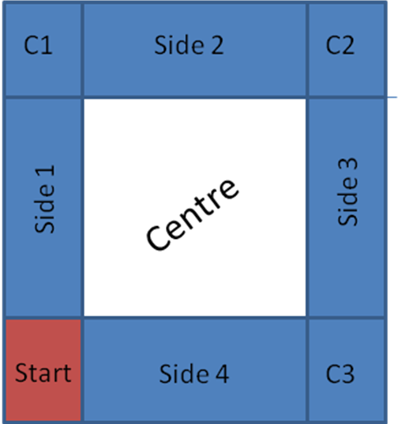

Fig. 5 arena for the open field test

3.6.1 Data analysis and statistics for the open field test
Open field test: the following measurements were obtained in the open field test, percentage of time spent in the centre of the arena, percentage of time spent in the periphery of the arena (blue areas) and latency to leave start position.
After transformation all variables were analysed with analysis of variance (ANOVA). For the different variables the following comparisons were made: differences between hens and roosters and differences between animals selected for low, intermediate and high fear response.

4 Results

4.1 Correlation in foraging and exploratory behaviour between different ages (P0)
Results from the replication of the foraging and exploratory test showed that there was a correlation between the two ages for two of three food choices (chicken food and meal worms), a trend towards correlation in the number of boxes visited and the number of changes between boxes, when all the birds are put together in one group. Females showed a significant correlation for chicken food and meal worms and a trend towards correlation in the number of changes between boxes. The results for the males showed a correlation on chicken food and meal worms, but not on any of the exploratory elements of the test.

Figure 6 shows the animals´ mean percentage of pecks in each of the three food sources at the two different ages. At the age of 13 weeks both females and males pecked more in the cups containing chicken food than in the cups containing wood shavings and meal worms, but there were significant differences between the sexes (P≤0.001), with the males directing about 65-80% of all pecks towards the cups with chicken food whereas the females only pecked in chicken food 50 % of total number of pecks.

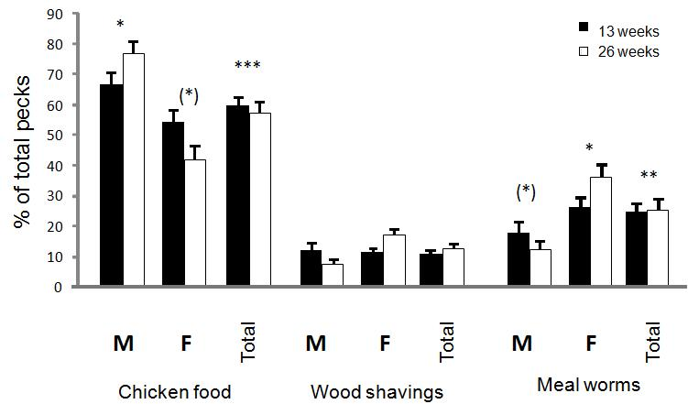

Figure 6. Correlation between the different food choices and age in P0 generation. Figures are given as a mean percentage of total pecks (error bars displaying standard error of mean). Significant correlation between the different ages are indicated ((*)=P≤0.1, *=P≤0.05, **=P≤0.01, ***=P≤0.001).

At the age of 26 weeks the males pecked even more in the cups containing chicken food whereas the females pecked less. When I combined the results from both sexes there was a significant correlation between the different ages (P≤0.001). On average birds of both sexes directed less than 20 % of their pecks at the cups with wood shavings, with females pecking more in the wood shavings at the age of 26 weeks and the males less. Here there was also a significant difference between the sexes (P≤0.001), but no correlation between the two ages. The females directed about 40 % of all their pecks at the cups with meal worm and wood shavings whereas the males only pecked at meal worm about 15 %. During the second trial males pecked even less while the females increased their number of pecks in order to search for more meal worms. When I combined the results from the two sexes there is correlation between the ages (P≤0.01).

Table 3. Correlations between the foraging and exploratory test at 13 weeks of age and 26 weeks of age.

 | Females |  | Males |  | All birds
 | Correlation Coefficient | p | Correlation Coefficient | p | Correlation Coefficient | p
Chicken Food | 0.4 | 0.02 | 0.5 | 0.007 | 0.5 | ≤0.001
Wood Shavings | 0.2 | 0.4 | 0.2 | 0.2 | 0.2 | 0.1
Mealworms | 0.4 | 0.02 | 0.3 | 0.07 | 0.3 | 0.006
Nr boxes | 0.2 | 0.2 | 0.2 | 0.2 | 0.2 | 0.08
Nr cups | 0.1 | 0.4 | 0.2 | 0.4 | 0.2 | 0.2
Nr of changes | 0.3 | 0.1 | 0.2 | 0.3 | 0.2 | 0.04

Figure 7 illustrates the mean number of boxes visited by the birds at the two different ages. Both males and females explored a greater number of boxes during their first test trial, at the age of 13 weeks, than during the second test, at 26 weeks. There was however a tendency (P≤0.1) towards correlation when results of the two sexes were combined. There was no significant correlation between the numbers of food cups that the animals explored at the two ages. However, males visited fewer food cups at 26 weeks than at 13 weeks while females visited slightly more cups at 26 weeks of age.

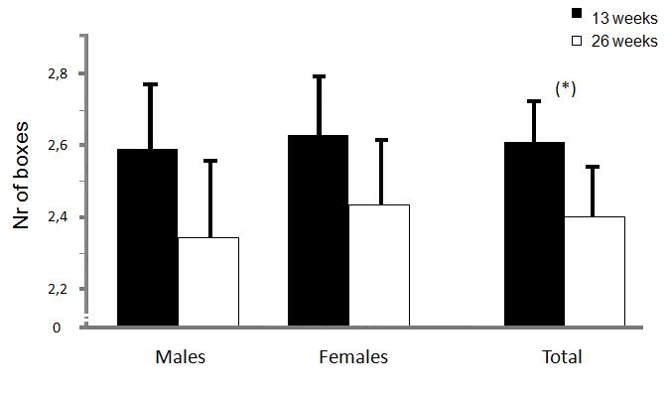

Figure 7. Mean number of boxes visited P0 generation at different ages. Error bars displaying standard error of mean. Significant correlation between the different ages are indicated ((*)=P≤0.1, *=P≤0.05, **=P≤0.01, ***=P≤0.001).

Figure 8 display the number of changes, between boxes, the bird made at the different ages. Both males and females moved between boxes somewhat more at the first trial session at 13 weeks than at 26 weeks. When the results of the two sexes were combined, there is a significant correlation (P≤0.05) between the two ages.

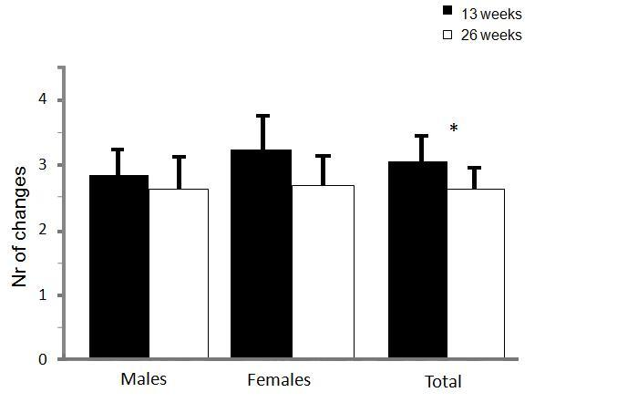

Figure 8. Mean number of changes between boxes in the P0 generation at different ages. Error bars displaying the standard error of mean. Significant correlation between the different ages are indicated ((*)=P≤0.1, *=P≤0.05, **=P≤0.01, ***=P≤0.001).

4.2 Comparisons between the first generation (P0) and the second generation (F1)
In the unselected P0 generation there were differences between the sexes in what they chose to feed on (Fig. 9). Roosters fed more on the easily available chicken food (P≤0.001, F=21.5) whereas the hens were more exploratory and searched for the meal worms that were camouflaged in wood shavings (P≤0.001, F=15.23). Females also pecked more in the cup with just wood shavings (P≤0.001, F=13.78). The figures, for the P0 generation, shows no significant differences between the selection lines, but it appears that females that were in the high selection group pecked more in the cups containing meal worms than either of the other groups. In the first selected generation, F1 (n=105), there were also sex differences between males and females, but not as clearly as in the first generation.

***
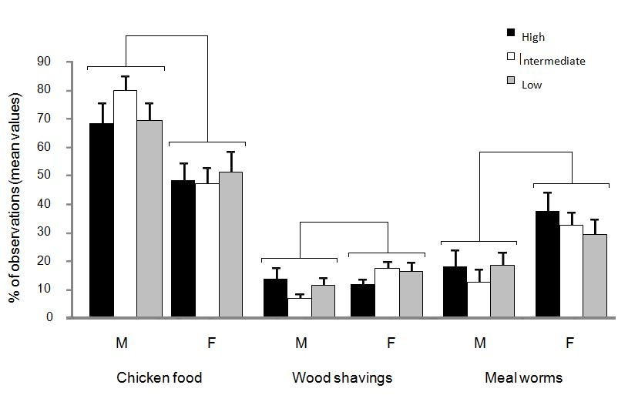
P0
***
***
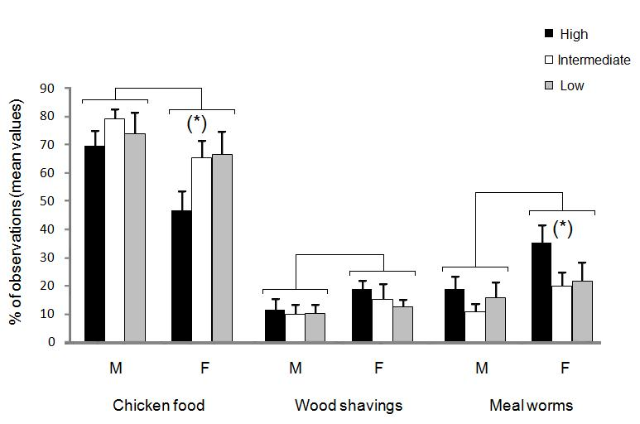
F1
*
(*)
(*)

Figure 9. P0 and F1 generations, all food choices. Figures given as mean percentage of observations (error bars displaying standard error of mean). Significant correlation between the different ages are indicated ((*)=P≤0.1, *=P≤0.05, **=P≤0.01, ***=P≤0.001).

Females pecked more in meal worms (P≤0.05, F=5.17) and males pecked more in chicken food (P≤0.01, F=7.78). In the first selected generation there were significant selection differences between the three selection groups. These differences could be seen in the number of pecks in chicken food (P≤0.05, F=3.44) and meal worms (P≤0.05, F=3.08). When I only looked at the females in the F1 generation there was a trend towards a difference between the three selection groups. High selected females pecked significantly less in cups with chicken food compared to females in the intermediate and low selection groups (P≤0.1, F=2.60), instead these females pecked more in the cups with meal worms covered in wood shavings (P≤0.1, F=2.52).

Figure 10 illustrates the mean number of boxes birds from the two generations visited. The results from the P0 generation showed no significant statistical differences between males and females and no significant differences between the three different selection lines.

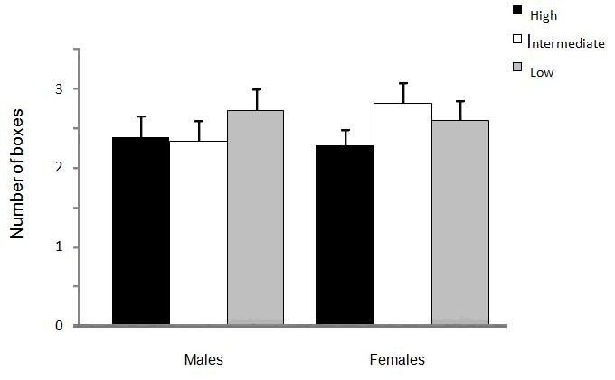
P0
**
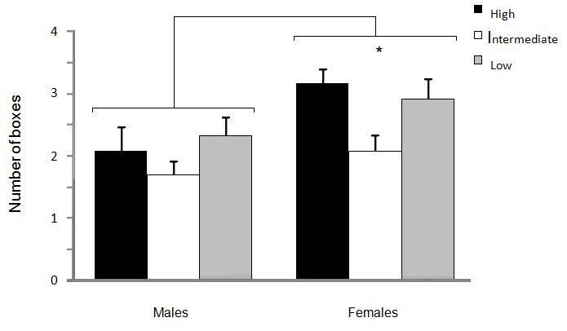
F1

Figure 10. Number of boxes visited. Mean number of boxes explored (error bars displaying standard error of mean). Significant correlation between the different ages are indicated ((*)=P≤0.1, *=P≤0.05, **=P≤0.01, ***=P≤0.001).

In the F1 generation there was a significant statistical difference between the sexes (P≤0.01, F=9.32), with females as the more explorative sex. A significant difference was also found between the three selection groups among the females (P≤0.05, F=4.68) were birds in the two extreme selection groups were more explorative than birds in the intermediate group.

Figure 11 shows the mean number of cups the birds explored during the test sessions. Results from the P0 generation show no statistical significant differences between the sexes and no significant differences between the three different selection groups. For the F1 generation data show significant differences between males and females (P≤0.01, F=7.97) with females exploring more cups than males. When I looked at only the females there were significant differences between the selection groups (P≤0.05, F=3.42) with birds from the two extreme selection lines being more explorative than the intermediate selection line.

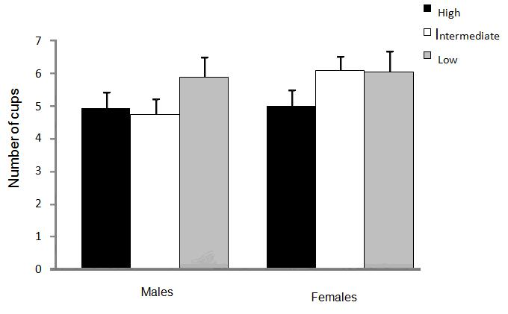
P0

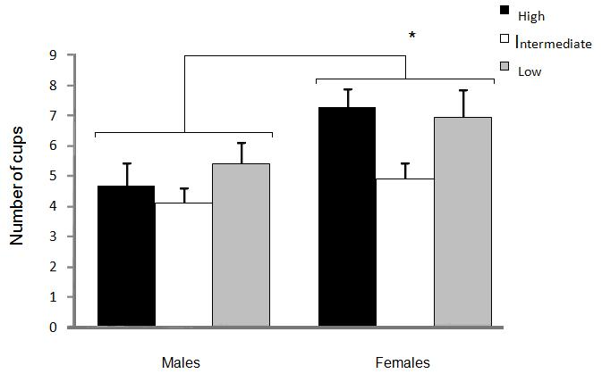
**

*
F1

Figure 11. Numbers of cups visited. Mean number of cups visited (error bars displayed as standard error of mean). Significant correlation between the different ages are indicated ((*)=P≤0.1, *=P≤0.05, **=P≤0.01, ***=P≤0.001).

Figure 12 shows the mean number of movements between boxes in the P0 and the F1 generation. Data from the P0 generation display no differences between the two sexes and no differences between the selection groups. Data from the F1 generation show significant differences between the sexes (P≤0.05, F=6.59) with males changing box significantly less than females, and significant differences between the selection groups in the female group (P≤0.05, F=4.22) with the two extreme groups performing more changes between boxes. The females in the intermediate group appears to be as explorative as most of the males.

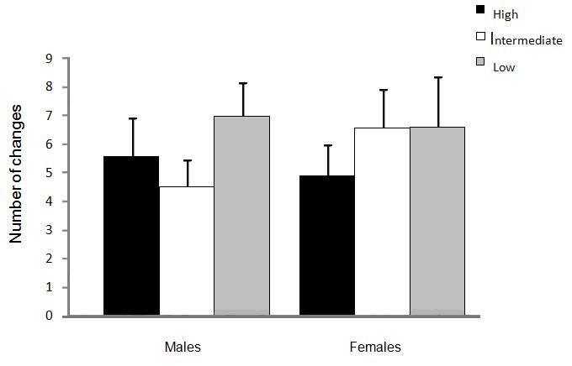

P0
*
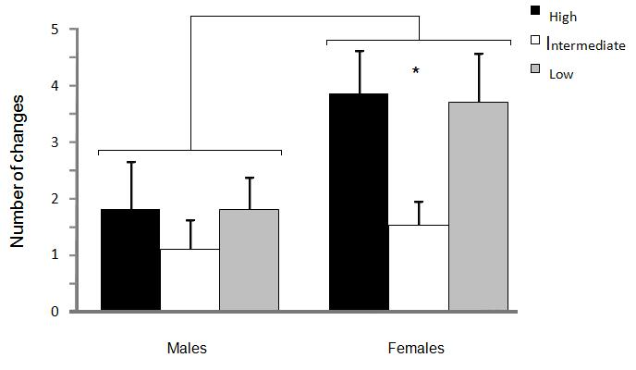
F1

Figure 12. Number of changes between boxes. Mean number of changes between the boxes (error bars displayed as standard error of mean). Significant correlation between the different ages are indicated ((*)=P≤0.1, *=P≤0.05, **=P≤0.01, ***=P≤0.001).

4.3 Undisturbed behaviour test (P0)
This test was only conducted on the P0 generation (n=75). Both males and females spent most of their time in foraging activities, exploring their surroundings or being active in some other way (walking, running or standing). Including all selection group’s significant differences were found between males and females for foraging/exploration, active, perch and comfort. In addition to this I found a significant difference between the three selection lines when I only looked at the females, for when I combine the behaviours of foraging/exploration and being active (P≤0.05, F=4.22) and a trend towards significant differences in the foraging/exploration behaviours (P≤0.1, F=2.55). But these significant differences between the selection groups can only be seen among the females. No statistical differences, between selection lines or sexes, were found for the behaviour category of inactive and jump/flight, so these figures are not shown here.

Figure 13 shows the mean percentage of time the animals spent foraging and explore their surroundings. This category is a fusion of three different behaviours, feeding/drinking, explore ground and explore objects. There were a significant difference between males and females (P=0.001, F=12.17) and a trend towards a difference among the selection groups among the females (P≤0.1, F=2.55). Females from the high selected group and males from the low selected group appear to spend an equal amount of time performing foraging behaviours and exploring the pen and objects in the pen.

***

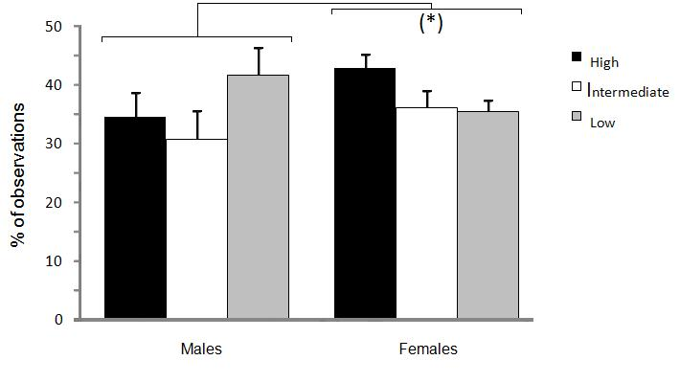
Figure 13. Percentage of observations (error bars displaying standard error of mean) of foraging and explorative behaviours in male and females. Significant correlation between the different ages are indicated ((*)=P≤0.1, *=P≤0.05, **=P≤0.01, ***=P≤0.001).

Figure 14 displays the mean percentage of time the animals were active during the test session. This category is composed of three different behaviours, walk, run and stand. There were a significant difference between the two sexes (P≤0.001, F=44.05) with females being more active.

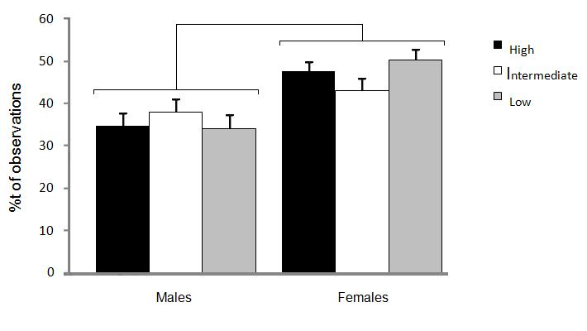
***
Figure 14. Percentage of observations (error bars displaying standard error of mean) of activity behaviours in males and females. Significant correlation between the different ages are indicated ((*)=P≤0.1, *=P≤0.05, **=P≤0.01, ***=P≤0.001).

Figure 15 shows the mean percentage of time the animals spent foraging/exploring and behaviours recorded as being active (walk, run or stand). There was a significant difference between the sexes (P=0.001, F=12.17) with females spending more time foraging and being active. When I only looked at the female group there was a significant difference between the selection groups (P≤0.05, F=4.22), with females from the high group being the most active.

***

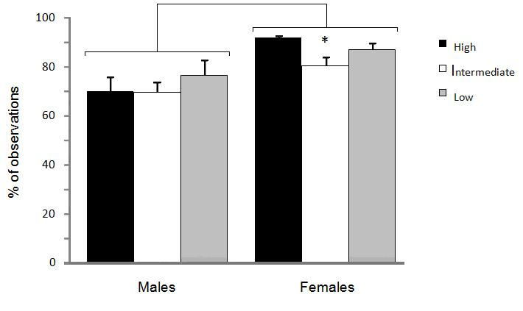
Figure 15. Percentage of observations (error bars displaying standard error of mean) of foraging and exploratory and active behaviours in males and females. Significant correlation between the different ages are indicated ((*)=P≤0.1, *=P≤0.05, **=P≤0.01, ***=P≤0.001).

Figure 16 shows the mean percentage of times the animals were perching during the test session. Significant difference were found between males and females (P=0.001, F=10.99) with males spending more time on the perch than the females.

***
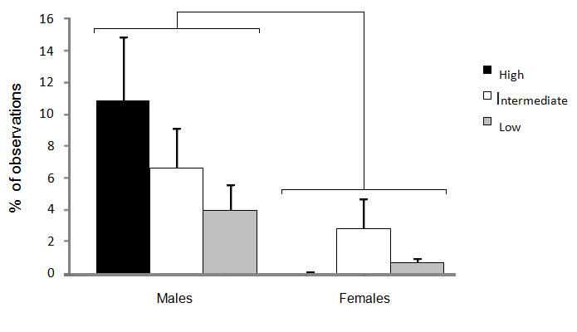
Figure 16. Percentage of observations (error bars displaying standard error of mean) of perching in males and females. Significant correlation between the different ages are indicated ((*)=P≤0.1, *=P≤0.05, **=P≤0.01, ***=P≤0.001).

Figure 17 shows the mean percentage of time the animals spent performing comfort behaviours (dust bath and preen behaviours). A significant difference was found between males and females (P=0.01, F=6.74).

*
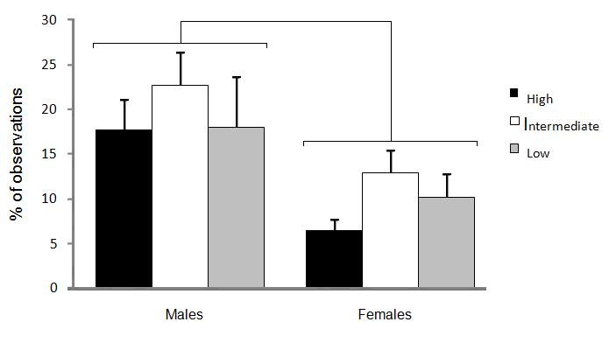

Figure 17. Percentage of observations (error bars displaying standard error of mean) of comfort behaviours in males and females. Significant correlation between the different ages are indicated ((*)=P≤0.1, *=P≤0.05, **=P≤0.01, ***=P≤0.001).

4.4 Open field test F1
These results derive from an open field test performed on the second generation (F1). All animals were tested twice and a mean value from each animal was used in the analysis. The results show that there were significant differences between the selection groups for the duration of time the birds spent in the centre and in the peripheral parts of the arena, but there were no differences between the sexes. When I analyzed the birds latency to leave the start position I found differences between the sexes but not between the selection groups.

Figure 18 shows the mean percentage of time spent in the centre of the arena. I found no significant difference between the sexes, but there were a significant difference between the three selection groups (P≤0.01, F=5.85), with birds from the low selection group spending more time in the centre than the two other groups.

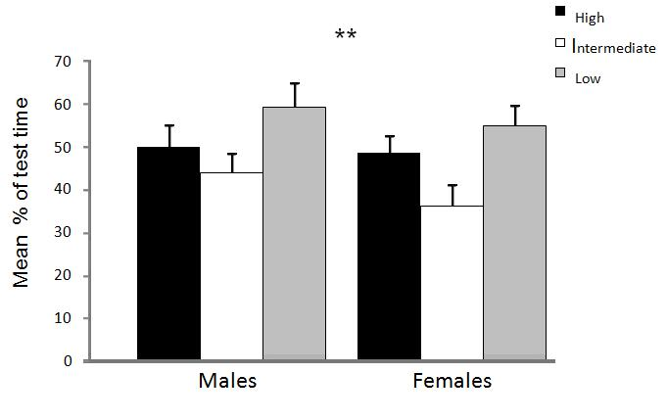
Figure 18. Mean percentage of time spent in the centre of the arena. Significant correlation between the different ages are indicated ((*)=P≤0.1, *=P≤0.05, **=P≤0.01, ***=P≤0.001).

Figure 19 display the mean time spent in the periphery of the arena, an arena consisting of the corners and the sides, as shown in figure 5. Again I found no significant difference between the sexes, but between the selection groups (P≤0.05, F=4.84) with birds from the intermediate group spending the most time in the periphery, followed by birds from the high line.

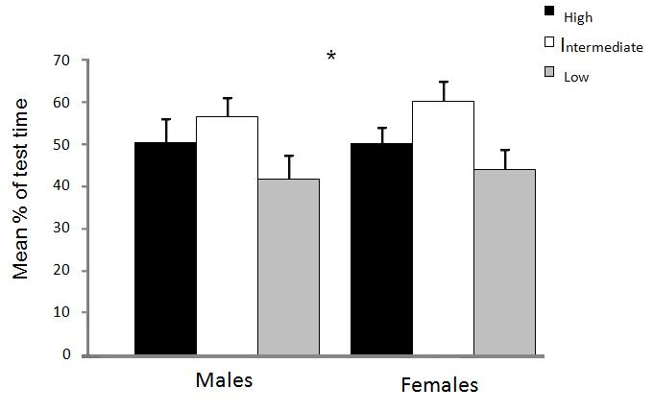

Figure 19. Mean percentage of time spent in the periphery of the arena (corners, sides and start position). Significant correlation between the different ages are indicated ((*)=P≤0.1, *=P≤0.05, **=P≤0.01, ***=P≤0.001).

Figure 20 shows the mean latency to leave the start position. From the start position the chicken could either follow the sides or venture into the centre of the arena. I found a trend towards significant differences between the sexes (P≤0.1, F= 2.82), with roosters leaving the corner earlier than females, but no significant difference between the selection groups. However, among the males it seem that roosters from the two extremes leaving sooner than the intermediate ones. Among the females this trend is also visibly with females from the low selection group being the first ones to leave.

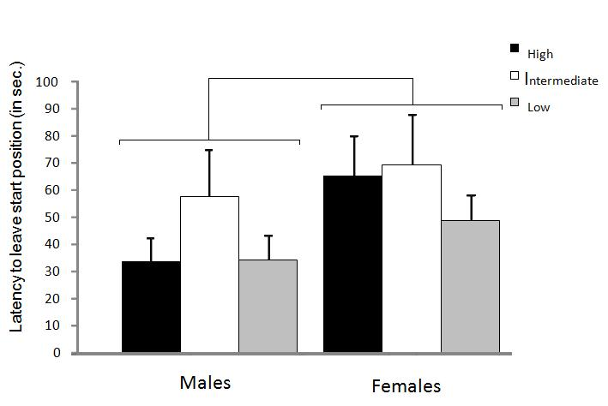
(*)

Figure 20. Mean latency to leave the start position. Significant correlation between the different ages are indicated ((*)=P≤0.1, *=P≤0.05, **=P≤0.01, ***=P≤0.001).

5 Discussion

My results show that when I compared the findings from the parental generation (P0) and the first offspring generation (F1), females from the F1 generation were significantly more explorative than males and that there were significant differences between the three selection lines, among the females, for all behaviours I analysed. My results also demonstrate that the foraging behaviour of chickens seems to be consistent over time, since the data from two out of three food choices correlated between the two trials I preformed with the parental generation. The number of changes between boxes and the number of boxes explored by the chickens also correlated between the ages, implying that exploratory behaviours also can be consistent over time. Results from the undisturbed behaviour test shows that females were slightly more active than the males, which performed somewhat more perching and comfort behaviours. There were differences between the selection lines among the females when I looked at the results of foraging, with females from the high selection group being the most active. Results from the open-field test prove that there were no significant difference between the sexes in the amount of time males and females spend in the centre or the periphery of the arena, but that there was a significant difference between the three selection lines.

5.1 Correlation in foraging and exploratory behaviour between different ages (P0)
In the beginning of this project I tested the parental generation, P0, at two different ages, 13 weeks and 26 weeks, in order to study whether foraging and exploratory behaviours change over time. At the age of 13 weeks both females and males pecked more in the cups containing chicken food than in the cups containing wood shavings and meal worms, but there were a significant differences between the sexes (P≤0.001). At the age of 26 weeks the males pecked even more in the cups containing chicken food whereas the females pecked less. On total there is correlation between the two ages (P≤0.001).
Birds of both sexes pecked less in the cups containing wood shavings than in those containing chicken food and meal worms, males pecking slightly more at the age of 13 weeks and females pecking a little more than males at the age of 26 weeks. This test does not indicate a correlation in the number of pecks in wood shavings between the ages. Females directed a higher number of pecks at the cups with meal worm and wood shavings at both ages, compared to the males, and there is a trend towards correlation between the two ages.
Both males and females visited fewer boxes during their second trial session compared the first session at age 13 weeks, but there were correlation between the ages (P≤0.01). At the age of 13 weeks males and females explored the same amount of cups, however during the second trial session males visited slightly less cups and females slightly more. I found no significant correlation between the two sexes at different ages. During the first trial session the females moved somewhat more between the boxes than the males, but in the second test at 26 weeks birds of both sexes moved between boxes the same amount of times. The correlation between the ages was significant (P≤0.05).
In total there is correlation between the number of pecks at 13 weeks and the number of pecks at 26 weeks for two out of three foraging options, indicating that the foraging behaviours of chicken appears to be consistent over time. This is somewhat contradictive to Lindqvist and Jensen (2008), how found that birds performed more foraging behaviours when they had reach sexual maturity than when young. The fact that males increased their number of pecks in chicken food could be derived from the fact that the food deprivation before the test affects the roosters more than the hens, due to their larger body mass (Schütz and Jensen, 2001). This is also supported by Inglis et al. (1997) that suggested that contrafreeloading decreased with increased hunger.
Both the number of boxes visited and the number of changes between boxes were correlated, signifying that the exploratory behaviour of chickens also could be consistent over time. The fact that both females and males were less exploratory as older could be due to the fact that they weigh more at 26 weeks than at 13 weeks, making it more energy demanding to move around in the arena. Some of the hens had started to lay eggs at 26 weeks, which should make them keener not to waste energy exploring. This is supported by a study performed by Braastad and Katle (1989) concluded that aggression and flight behaviours was the most energy-demanding activities in laying hen, followed by walking and pecking at food.

5.2 Comparisons between the first generation (P0) and the second generation (F1)
Males in the parental generation pecked significantly more in chicken food than the females, who were significantly more explorative and pecked in the cups containing meal worms. This pattern is repeated in the next generation where the high selected females pecked almost as much in both chicken food and meal worms. This resulted in a trend towards significant differences between the three selection lines among the females. In the parental generation the data show that both males and females are equally exploratory whereas the females are more exploratory than the males in the first selected generation. One explanation for this could be that the roosters were more fearful of the arena or of me as an observer. A study performed by Campler and colleagues (2009) showed that Red Junglefowl hens moved around more in the arena than the Red Junglefowl roosters.
The results also show that there are significant differences between the three selection lines among the females of the second generation. However it appears as if it is the high and the low line that are about evenly exploratory. If we consider the most fearful birds, the high line, as most like the “wild-type” I would have expected them to be the most exploratory, e.g. explore more food choices, perform more contrafreeloading and move around more between boxes, since this explorative behaviour can be viewed as an adaptive behavioural strategy in a natural environment (see Andersson, 2001). One could also look at the energy content in standard chicken food and meal worms. If meal worms contain a lot more energy than chicken food then it would be more energy efficient to search for meal worms even if it appears to be a more costly feeding strategy. The differences between the selection lines among the females could also be explained by the fact that the test that measures fear of humans is more sensitive in one end of the distribution. If we were to look at one selection line at a time and compare it to the two others together, there would be a difference between the high line and the combined results of the intermediate and low lines.

5.3 Undisturbed behaviour test P0
When the animals were studied without being disturbed both males and females spent most of their time feeding, exploring the pen or being active (running, walking or standing). Females spent about 40 % of their time budget feeding and searching for food and around 50 % being active. The males spent approximately 40 % of their time being active and the same amount of time on foraging behaviours. The results from this test points towards a significant difference between the selection groups in the female group but not amongst the males. Dawkins (1989) reported that free-ranging Red Junglefowl in captivity spend a great part of their active time feeding and performing foraging behaviours like scratching and ground pecking. Figures 14 and 16 show that females from the high selected groups are the once that spent more time feeding and explore the pen and being active than the other two selection groups, which make sense if we consider the high selection group as being the most “wild type” like of the three selection groups.
The roosters spent a significantly higher percentage of their time perching than the females, and males from the high selection group spent the highest amount of time on the perch. This could be due to the chore distribution in a wild flock, with one male surveying several females. Males also performed significantly more comfort behaviours (dust bath and preening) than the females. Again, this could be attributed to the fact that rooster are heavier than the hens which make them less prone to engage in more energy demanding behaviours such as exploring surroundings and objects.

5.4 Open field test F1
Results from the open field arena show that there is a significant difference between the three different selection lines in two of the three behaviour responses measured in the test, percentage of time spent in the centre of the arena and percentage of time spent in the periphery of the arena. Results show that birds from the low selection line, birds that display a tamer and domesticated behaviour towards humans, spend more time in the centre of the arena, where they are more exposed to dangers. Females appeared to spend less time in the centre than the males but there were no statistically significant difference between the two sexes. The second behaviour measured in the test was the percentage spent in the periphery of the arena, along the walls. There was a significant difference between the selection lines with animals from the intermediate line spending significantly more time in the periphery followed by birds from the high line. This is in accordance with other studies that show that animals that display a more fearful behaviour spend most time in the periphery of the arena (Archer, 1975). Results from the last behaviour measured, latency to leave starting position, show that males moved sooner than the females and that birds from the intermediate line moves before birds from the two other selection lines. Other studies have demonstrated that hens normally move sooner than roosters do (Campler et al, 2009) implicating that rooster´s normally is more fearful of new surroundings. In a review article Archer (1975) demonstrates that behavioural studies on rodents in an open field arena has given different results about which sex that is most afraid to leave the starting position. In general female mice and rats ambulate more in an open field test than what males do, suggesting that males are more afraid of the whole situation (Archer, 1975). Another important measurement that is not mention in this open field test is the total distance an animal moved during the test time. Several studies have shown that rodent females have more active exploration behaviour than males (Archer, 1975) and Forkman et al (2007) pointed out that immobilisation and freezing is perhaps a better indicator of fear-related responses than increased activity and flight response. Immobilisation could be said to be measured by the latency to leave starting position and a complement to this measurement could be the total distance moved.

In this present study I found significant selection responses among the females of the second generation (F1) and among the females for some behaviours (foraging and exploratory behaviours and when I combine foraging and exploratory and active behaviours in the undisturbed behaviour test) the first (P0). Selection responses occurred in foraging and exploratory behaviours indicating that both these behaviour categories are affected by the domestication process. Hens from the low and the intermediate selected lines in the F1 generation pecked more in the chicken food than their mothers in the P0 generation, whereas the hens from the high selection lines of both generations pecked an equal amount of times in the chicken food. All females in the F1 generation pecked about 40 % in the cups containing meal worms while in the P0 generation only the females from the high line pecked so much in the meal worms. With regard to the number of boxes and cups visited there were no difference between the generations, but the hens of the P0 generation moved more between the boxes than their daughters.

5.5 Conclusion
In conclusion, there were differences between males and females in foraging and exploratory behaviours, with females being the more explorative sex. In the second generation (F1) I have found significant selection responses among the hens but not the roosters. I also found significant differences between males and females in the time they spent active, perching and performing comfort behaviours. However, this is just two generations and more studies are necessary to be able to really study the effects of domestication based on fear of humans in Red Junglefowl.

6 Acknowledgements
I would like to thank my supervisor, Professor Per Jensen, for his guidance and support throughout the work with this thesis. I would also like to thank Markus Jöngren and Beatrix Eklund for letting me be a part of their PhD project during this year. In addition to these three I thank Mia, Sara and Martin for the fun we have had in the office during this year. Couldn’t have done it without you guys. And of course my family and friends outside the University.

7 References

Al-Nasser, A., Al-Khalaifa, H., Al-Saffar, A., Khalil, F., Al-Bahouh, M., Ragheb, G., Al-Haddad, A., Mashaly, M. 2007. Overview of chicken taxonomy and domestication. World´s Poultry Science Journal, 63, 285-300

Albert, F. W., Shchepina, O., Winter, C., Rompler, H., Teupser, D., Palme, R., Ceglarek, U., Kratzsch, J., Sohr, R., Trut, L. N., Thiery, J., Morgenstern, R., Plyusnina, I. Z., Schoneberg, T. & Paabo, S. 2008. Phenotypic differences in behavior, physiology and neurochemistry between rats selected for tameness and for defensive aggression towards humans. Hormones and Behavior, 53, 413.

Andersson, M., Nordin, E., Jensen, P. 2001. Domestication effects on foraging strategies in fowl. Applied Animal Behaviour Science, 72, 51-62

Archer, J. 1975. Rodent sex differences in emotional and related behaviours. Behavioural biology, 14, 451-479

Bean, D. Mason, G.J., Bateson, M. 1999. Contrafreeloading in starlings: testing the information hypothesis. Behaviour 136, 1267-1282

Belyaev, D. K., Plyusnina, I. Z. & Trut, L. N. 1984. Domestication in the silver fox (Vulpes fulvus desm.) - changes in physiological boundaries of the sensitive period of primary socialization. Applied Animal Behaviour Science, 13, 359-370.

Braastad, B. O. and Katle, J. 1989. Behavioural differences between laying hen populations selected for high and low efficiency of food utilisation, British Poultry Science. 30, 533-544

Campler, M., Jöngren, M., Jensen, P. 2009. Fearfulness in red junglefowl and domesticated White Leghorn chickens. Behavioural Processes, 81, 39-43

Clotton-Brock, J. 1999. A Natural History of Domesticated Mammals. Cambridge University Press, Cambridge.

Collias, N.E and Collias, E.C. 1967. A field study of the red jungle fowl in north-central India. The Condor, 69, 360-386

Collias, N.E and Collias, E.C. 1996. Social organization of a red junglefowl, Gallus gallus, population related to evolution theory. Anim. Behav. 51, 1337–1354

Collias, N.E and Saichuae, P. 1967. Ecology of the red jungle fowl in Thailand and Malaya with reference to the origin of domestication. Natural History Bulletin of the Siam Society, 22, 189-209

Dawkins, M.S. 1989. Time budgets in red junglefowl as a baseline for the assessment of welfare in domestic fowl. Applied Animal Behaviour Science. 24, 77-80

de Jonge, F. H., Tilly, S-L., Baars, A. M., Spruijt, B. M. 2008. On the rewarding nature of appetitive feeding behaviour in pigs (Sus scrofa): Do domesticated pigs contrafreeload? Applied Animal Behaviour Science, 114, 359-372

Duncan, I.J.H and Hughes, B.O. 1972. Free and operant feeding in domestic fowl. Anim. Behav. 20, 775-777

Forkman, B. 1991. Problems with current patch-choice theory: a study on the Mongolian gerbil. Behaviour 117, 243-254

Forkman, B., Boissy, A., Meunier-Salaun, M.-C., Canali, E., Jones, R.B. 2007. A critical review of fear tests used on cattle, pigs, sheep, poultry and horses. Physiology and Behavior 92, 340-374

Fumihito, A., Miyake, T., Sumi, S-I, Takada, M., Ohno, S., Kondo, N. 1994. One subspecies of the red junglefowl (Gallus gallus gallus) suffices as the matriarchic ancestor of all domestic breeds. Proc. Natl. Acad. Sci., 91, 12505-12509

Gustafsson, M., Jensen, P., de Jonge, F. H., Schuurman, T. 1999. Domestication effects on foraging strategies in pigs (Sus scrofa). Applied Animal Behaviour Science, 62, 305-317

Håkanson, J., Jensen, P. 2005. Behavioural and morphological variation between captive populations of red junglefowl (Gallus gallus) - possible implications for conservations. Biological Conservation, 122, 431-439

Håkanson, J., Bratt, C., Jensen, P. 2007. Behavioural differences between two captive populations of red jungle fowl (Gallus gallus) with different genetic background, raised under identical conditions, Applied Animal Behaviour Science, 102, 24-38

Håkansson, J. 2007. Behavioural aspects of conservation breeding, Red junglefowl (Gallus gallus) as a case study. Linköpings Studies of Science and Technology. Dissertion No. 1137

Inglis, I.R, Forkman, B, Lazarus, J. 1997. Free food or earned food? A review and fuzzy model of contrafreeloading, Anim. Behav., 1997, 53, 1171–1191

Jensen, P. 2006. Domestication- From behaviour to gens and back again. Applied Animal Behaviour Science 97, 3-15

Kaul, R., Shah, J. N., Chakrabarty, B. 2004. An assessment of important physical traits shown by captive red junglefowl in India. Current science, 87, 1498-1499

Lankin, V. 1997. Factors of diversity of domestic behavior in sheep. Genet Sel Evol, 29, 73-92

Lindqvist, C. E. S., Schütz, K. E., Jensen, P. 2002. Red Jungle Fowl have more contrafreeloading than white Leghorn layers: Effects of food deprivation and consequences for information gain. Behaviour, 139, 1195-1209

Lindqvist, C. 2008. Domestication effects on foraging behaviour- consequences for adaptability in chickens. Linköping Studies in Science and Technology, Dissertation No. 1164

Lindqvist, C., Jensen, P. 2008. Effects of age, sex and social isolation on contrafreeloading in red junglefowl (Gallus gallus) and White Leghorn fowl. Applied Animal Behaviour Science, 114, 419-428

Lindqvist, C., Lind, J., Jensen, P. 2009. Effects of domestication on food deprivation-induced behaviour in Red Junglefowl, Gallus gallus, and White Leghorn layers. Animal Behaviour, 77, 893-899

Neuringer, A.J. 1969. Animals respond for food in the presence of free food. Science 166, 399-401

Osborne, S. R. 1977. The free food (contrafreeloading) phenomenon: A review and analysis. Animal Learning & Behavior, 5 (3), 221-235

Price, E. O. 1984. Behavioral aspects of animal domestication. The Quarterly Review of Biology, 59 (1), 1-32

Price, E. O.1999. Behavioral development in animals undergoing domestication. Applied Animal Behaviour Science, 65, 245-271

Savory, C.J. 1980. Diurnal feeding patterns in domestic fowl: A review. Applied Animal Ethology 6, 1, 71-82

Schütz, K., Jensen, P. 2001. Effects of Resource Allocation on Behavioural Strategies: A Comparison of red junglefowl (Gallus gallus) and Two Domesticated Breeds of Poultry. Ethology, 107, 753-765

Schütz, K., Forkman, B., Jensen, P. 2001. Domestication effects on foraging strategy, social behaviour and different fear responses: a comparison between the red jungle fowl (Gallus gallus) and a modern layer strain. Applied Animal Behaviour Science, 74, 1-14

Trut, L., Oskina,I., Kharlamova, A. 2009 Animal evolution during domestication: the domesticated fox as a model. BioEssays, 31, 349–360

West, B., Zhou, B.-X. 1989. Did chickens go north? New evidence for domestication. World`s Poultry Science Journal, 45, 2005-218

Zeuner, F.E. 1963. A History of Domesticated Animals. Hutchinson of London. London.

24

