Department of Physics, Chemistry and Biology

Master Thesis

Effect of Tree-Fall Gaps on Fruit-Feeding Nymphalidae Assemblages in a Peruvian Rainforest

Sylvia Pardonnet
LiTH-IFM- Ex--2309--SE

Supervisors: Karl-Olof Bergman & Per Milberg, Linköpings universitet Harald Beck, Towson university (Mariland, USA)
Examiner: Anders Hargeby, Linköpings universitet

Department of Physics, Chemistry and Biology
Linköpings universitet
SE-581 83 Linköping, Sweden

Rapporttyp
Report category

Licentiatavhandling
X Examensarbete
C-uppsats
D-uppsats
Övrig rapport

_______________
Språk
Language

Svenska/Swedish
X Engelska/English

________________
Titel
Title

Effect of Tree-Fall Gaps on Fruit-Feeding Nymphalidae Assemblages in a Peruvian Rainforest

Författare
Author

Sylvia Pardonnet
Sammanfattning
Abstract

Tropical rainforests are among the most complex and diverse ecosystems, composed of a mosaic of shady understory under the closed canopy and tree-fall gaps of varying sizes and age. The light reaching the forest floor favors the recruitment of fast growing plant species and provide food resources for other animal species including butterflies. The Nymphalidae are the most species rich butterfly family in the tropics, and are ideal bioindicators. We investigated the effect of the tree-fall gaps on the assemblages of fruit feeding Nymphalidae. We used fruit-bait traps in 15 tree-fall gaps from 100 to 1000 m² and 15 in undisturbed understory, from July until November, in a lowland tropical rainforest in southeastern Peru. We found distinct differences in butterfly assemblages between tree-fall gaps and understory, with a higher number of species in gaps, associated with a higher level light. We identified several species mostly found in one of the habitats, and generalist species. The heterogeneity was large within the same site both in gaps and in the understory. The difference between butterfly assemblages increased with gap size. Butterfly species were mainly associated with the absence of vines in the gaps, and found in large and light gaps. We distinguished several species according to their preferences for the vegetation structure, light level and size of gaps. We concluded that one example that maintains the biodiversity in the tropical rainforest is the formation of tree fall gaps of different sizes resulting in different species assemblages.
ISBN
__________________________________________________
ISRN
__________________________________________________

Serietitel och serienummer ISSN
Title of series, numbering

LITH-IFM-A-Ex—10/2309--SE
Nyckelord
Keyword

Intermediate disturbances, Gap dynamics, Amazonian Lepidoptera

Datum
Date

2010-06-04
URL för elektronisk version
Avdelning, Institution
Division, Department

Avdelningen för biologi
Instutitionen för fysik och mätteknik

Contents

Abstract 1
Introduction 1
Material and methods 2
Study site 2
Measurement of site variables 3
Butterfly trapping 3
Statistical analyses 4
Results 4
Discussion 9
Butterfly assemblages in gaps and understory 9
Comparison of butterfly assemblages among gaps 10
Importance of heterogeneity 10
Acknowledgments 11
References 11

Effect of Tree-Fall Gaps on Fruit-Feeding Nymphalidae Assemblages in a Peruvian Rainforest

Abstract
Tropical rainforests are among the most complex and diverse ecosystems, composed of a mosaic of shady understory under the closed canopy and tree-fall gaps of varying sizes and age. The light reaching the forest floor favors the recruitment of fast growing plant species and provide food resources for other animal species including butterflies. The Nymphalidae are the most species rich butterfly family in the tropics, and are ideal bioindicators. We investigated the effect of the tree-fall gaps on the assemblages of fruit feeding Nymphalidae. We used fruit-bait traps in 15 tree-fall gaps from 100 to 1000 m² and 15 in undisturbed understory, from July until November, in a lowland tropical rainforest in southeastern Peru. We found distinct differences in butterfly assemblages between tree-fall gaps and understory, with a higher number of species in gaps, associated with a higher level light. We identified several species mostly found in one of the habitats, and generalist species. The heterogeneity was large within the same site both in gaps and in the understory. The difference between butterfly assemblages increased with gap size. Butterfly species were mainly associated with the absence of vines in the gaps, and found in large and light gaps. We distinguished several species according to their preferences for the vegetation structure, light level and size of gaps. We concluded that one example that maintains the biodiversity in the tropical rainforest is the formation of tree fall gaps of different sizes resulting in different species assemblages.

Keywords: Intermediate disturbances, Gap dynamics, Amazonian Lepidoptera

Introduction
Tropical rainforest are among the most complex and species rich-habitats on earth, harboring as much as two thirds of all the living animal and plant species (Beck, 2008; Waide, 2008). Numerous mechanisms that promote and maintain tropical species richness have been suggested e.g. pest pressure, specialization and disturbance (Leigh et al., 2004). The principal natural disturbance factor affecting the structure of rainforests are tree falls creating the gaps, which consist of an opening of the canopy that allows the sun light to reach the forest floor. Tree-fall gaps differ in their characteristics, like their size, depending on levels of intensity, frequency, extent and duration of the disturbances (Shea et al., 2004). The effect of the tree fall gaps is that tropical rainforests can be considered as a mosaic of micro-successional patches (Terborgh, 1992). The intermediate disturbance hypothesis proposes that the highest diversity is maintained at intermediate scales of disturbance (Connell, 1978). Empirical evidences that support this hypothesis have been reported for a wide range of species (Molino & Sabatier, 2001; Terborgh, 1992; Tomlinson, 1991; Hill et al., 2001).
Light is a major limiting factor in tropical forest (Chazdon et al., 1996), and the higher amount of light found in gaps leads to higher productivity compared with the closed forest (Denslow, 1987), playing an important role in plant species composition (Hubbell et al., 1999; Schnitzer & Bongers, 2002). Because of increased sun radiation some trees produce more fruits in the gaps than in the understory (Pinero, 1984; Denslow et al., 1986; Levey, 1990), and could attract more species e.g. birds (Levey, 1988), butterflies (Hill et al., 2001), and mammals (Beck, 2002; Beck et al., 2004). The great amount of resources provided by plant species growing in the gaps, compared to the understory, may favor many species feeding on them (Spitzer et al., 1997), e. g. butterflies.
Of the rainforest in the world, the Amazon rainforest is considered to host the greatest diversity of organisms (Olson & Dinerstein, 2002). The diversity found in the rainforests has been studied using assemblages of plants (Denslow, 1987), birds (Levey, 1988), mammals (Beck et al., 2004) and insects (DeVries et al., 1997; Hamer et al., 2003). Among these taxa, butterflies are often chosen as biological indicators (Lamas, 1997; Kremen, 1992; Hill et al., 2001; Fermon et al., 2005). Out of approximately 7000 species of butterflies found in the Neotropics, over 3500 occur in Peru (Lamas, 1997; DeVries, 1987). In Peru, where 60% of the territory is still covered with tropical rain-forest (Lamas, 1997), the national park of Manu offers a completely undisturbed ecosystem (Terborgh, 1992). The family Nymphalidae represents the most specious butterfly family, and they are also the largest family occurring in Peru (Lamas, 1997; Murray, 2000). Because of the butterflies distinct visibility (size and color) they are ideal models to address numerous ecological questions (e.g. DeVries, 1988; Hamer et al., 1997; DeVries et al., 1997, 1999; Shahabuddin & Terborgh, 2000). One widely used subgroup is the fruit-feeding nymphalids, which consist of species where adults feed on the juices of rotting fruit (DeVries et al., 1997, 1999).
Studies of butterflies conducted in rainforests have been focused on describing patterns of butterfly communities (DeVries et al., 1999; Fermon et al., 2005), using them as indicator species (Kremen, 1992), comparing faunas at different sites (Lamas, 1997), and impact of logging (Hamer et al., 2003; Hill et al., 2001; Fermon et al., 2005). Studies trying to describe the mechanisms affecting butterfly diversity in undisturbed rainforest had received less attention, with a few exceptions (Hill et al., 2001; Hamer et al., 2006).
In this study, we compared the assemblages of fruit-feeding Nymphalidae found in the undisturbed understory and natural tree-fall gaps of different sizes. Our hypothesis was that different nymphalids assemblages would occur in tree-fall gaps compared to the undisturbed understory. Furthermore because it has been shown that plant communities vary with gap size, we expect to find different densities and species by gap size.

Material and methods

Study site
The study was conducted in south-eastern Peru, at the Cocha Cashu Biological Station EBCC in the Manu National Park (11°51′23″S 71°43′17″W). With over 2 million hectare, Manu is one of few sites around the world where diverse assemblages of plants and animals remain intact and accessible for study. The average annual rainfall is about 2300 mm, with most precipitation falling between November and May. Mean annually temperatures ranges from 9°C to 34°C. The study area consists of approximately 10 km² lowland tropical evergreen rainforest (Terborgh, 1990).
We selected 15 gaps according to a gradient of size, from ~100 m² up to ~1000 m², with a minimum distance of 100 m between them. An additional of 15 undisturbed understory control sites were chosen by taking a random direction from the center of a gap, and they were placed at a >50 m from the center of the gap. If the understory site encountered another gap, another random direction was chosen.
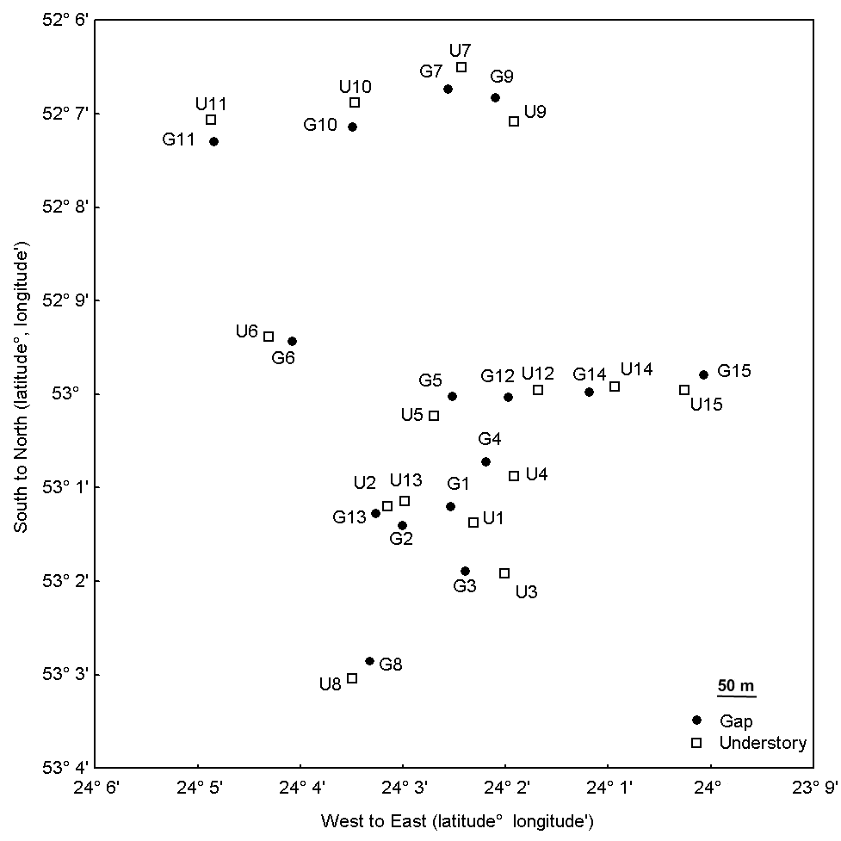
Figure1: Spatial distribution of the gaps and their understory control sites, named according to the gradient of gap size at Manu National Park, Peru.

Measurement of site variables
Gap sizes were estimated using the Brokaw (1982) method. The study area of the understory sites was determined following the same directions and size as the associated gap site.
The amount of incoming sunlight was measured in each tree-fall gap and understory controls, using an incident light meter. The light was measured at seven locations (five along the length and two along the width) within each site, between 11 am to 2 pm during day without cloud cover.
We recorded the number, height, and diameter of woody plants and vines in each site, using ten plots of 1 m², placed randomly in gaps and their control sites. The plants were classified into vines and woody plants.

Butterfly trapping
The butterflies were trapped in baited traps (Sutherland, 2006; DeVries, 1987) consisting of a 65 cm long cylinders of black nylon mesh with a diameter of 30 cm. A 35 cm plastic plate used for baiting were placed approximately 3 cm below the cylinder. The traps were placed along the length of each site, at one third and two third of the total length. Following Tangah et al. (2004) the traps were attached to branches, approximately 2 m above the ground level. A total of 60 bait traps, two traps within each tree-fall gap and two in the associated understory were used, resulting in 15 pairs. The trapping period, for five consecutive days per week, started at the beginning of July and ended at the end of October 2009, covering 13 weeks.
Each trap was baited with one overripe banana and some drops of vanilla extract. We trapped. The bait was enclosed within a metal mesh to reduce predation by other species but still allowing the butterfly’s proboscis free access. Each trap was re-baited every second day, and the bait was left in the trap for the rest of the study, which ensured that all traps contained a mixture from overripe to well-rotten bait.
All butterflies were identified to species if possible, following the nomenclature and classification from Lamas (2004).

Statistical analyses
Of the total number of butterflies in traps, 2.7% remained unidentified (escaping during handling, or damaged body parts like wings), and they were excluded from analyses.
Species accumulation curves by trap as well as over time were done using EstimateS Ver 7.51, using the number of species observed (Mau Tao index) and the number of species expected (Chaos 2 index). Chao 2 was chosen as nonparametric estimator as it performs well on small samples (Colwell & Coddington, 1994) and has been considered as the least biased estimator dealing with total species richness (Bruno & Moore 2005). These analyses were used to evaluate the success of the sampling and to estimate the total richness in the area.
Multivariate statistical analyses were performed with the CANOCO 4.5 software package (ter Braak and Smilauer, 2002) using multivariate methods based on linear assumptions, as the beta-diversity in the data was relatively low (following recommendations by Leps and Smilauer, 2003). Species data were transformed (log₁₀(x+1)) in order to minimize the impact of very abundant species.
A first principal component analysis (PCA) compared the species composition in traps in understory and gap, with the light level included as a passive environmental variable.
A strict test of our assumption about the importance of gap size needs to consider the pair-wise nature of our data. We therefore used χ² distances within each pair of site, and the hypothesis that this measure of dissimilarity in composition would increase with gap size (linear regression). χ² distances were based on transformed species data (log₁₀(x+1)) and gap sizes were square-root transformed.
A second PCA involved only data from gaps, to assess the influence of gap size and including passive environmental variables describing vegetation structure (density, height, and diameter of vines and woody plants).
To further highlight the differences between gaps and understory traps, a partial redundancy analysis (pRDA) was conducted. This involved gap/understory as the only (categorical) environmental variable and trap-pair identity as a number of categorical covariables (thereby eliminating some of the potential spatial variation in the data). The statistical significance of the model was assessed in a Monte Carlo permutation test (9999 permutations). Furthermore, the model differentiated gap vs. understory specialist species. Finally, the species scores in the pRDA were correlated with the morphological data (log transformed), using the average of records per species.

Results
A total of 1531 individuals distributed among 82 fruit-feeding Nymphalid species were captured during a 13 weeks study period (excluding 66 recaptures (4.3%) and 42 unidentified individuals (2.7%)). The number of individuals varied between 7 and 65 and the number of species between 5 and 22 for the gap traps and between 11 and 57 individuals and between 3 and 13 species for the understory sites. In total, 791 individuals were trapped in the gaps and 806 individuals in the understory. The species Panacea prola was numerically dominant, representing 60.7% of the total number of individuals, both in gaps (52.3%) and understory (68.9%) habitat.

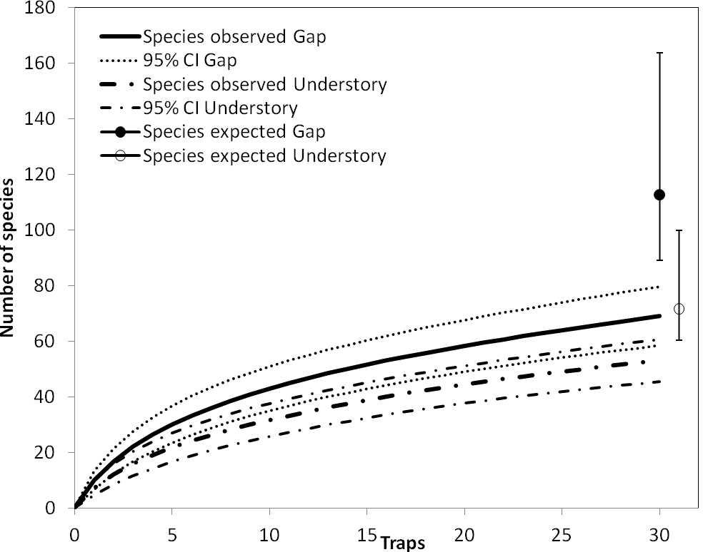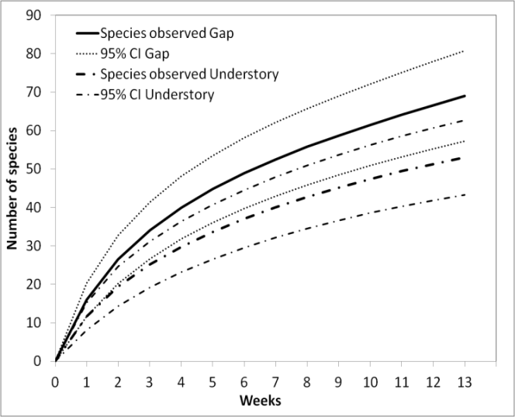
a
b
Figure 2. Species accumulation curves by traps (a) in a total of 30 traps, and by weeks (b) during 13 weeks, in gaps and understory. The estimated species richness in gaps and understory was calculated with the non-parametric estimator Chaos 2 (a). Each curve is presented with a 95% confidence interval.
In total, 50 species were found in the understory and 71 in the gaps. Also the estimated richness (Chao 2 index) indicated a difference between gaps and understory and species richness was also higher (38%) in the gaps than in the understory (Fig.2a). The time-based accumulation curves showed a relatively steep increase with time, suggesting temporal differences in flight periods.

The PCA run to investigate the differences in butterfly assemblages between gaps and understory (Fig.3) revealed that there were overall larger differences between butterfly assemblages in gap traps than between understory traps. In many cases there were large differences even between the pair of traps close to each other in both gaps and understory. However, the butterfly assemblages from trap pairs from the understory control sites were in general more similar than the assemblages in the gap pairs (Fig 3a-b).
There was a clear difference in the butterfly species assemblages with gap and understory sites (Fig.3c). The majority of the species were associated with the gaps and with increasing light level. The species Adelpha jordani, Memphis glauce, Temenis laothoe, and Zaretis isidora showed the strongest association with gaps, showing a preference of higher amount of light, contrasting with Tigridia acesta and Nessea obrinius which were associated with the understory.

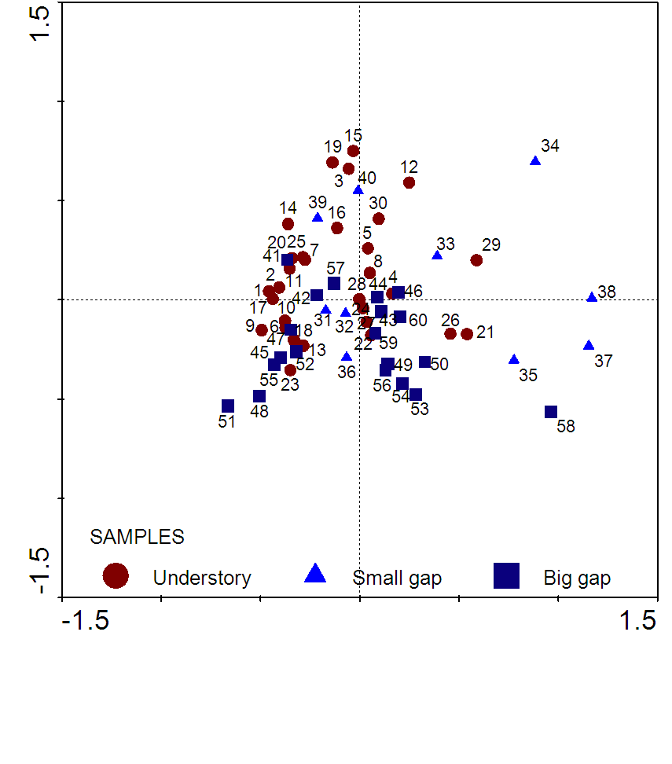
a
b
c
Figure 3. PCA ordination diagram of butterfly communities from traps in gaps (a), divided in small (< 300m²) and big gaps (> 300m²), and understory (b), linked by pair, and PCA ordination diagram of butterfly communities and environmental variables (c). Only the 22 species that contribute most to the model are shown. Eigenvalues of First Principal Component (PC1, x axis) and PC2 (y axis) are 17.5 and 10.7.

The pRDA, performed to investigate the degree of species’ association with gaps vs. understory, indicated that the species associated with the understory contained relatively few species, including Tigridia acesta, Catoblepia berecynthia and C. xanthus, and Nessea obrinius (Table 1). The “gap specialists” were more numerous with Pyrrhogyra crameri, Temenis laothoe, Archeoprepona demophon, Morpho helenor, Adelpha jordani, A. iphiclus, Memphis glauce and M. basiles as the most distinct ones (Table 1). We could also distinguish non-specialists, i.e. those with pRDA scores close to zero, e.g. Ps valentina.

Table 1. pRDA scores of the log transformed data, with habitat as explanatory variable and pairs of traps as covariable. P-values were given by Monte-Carlo permutation tests with 9999 permutations (Trace=0.048, F-ratio=3.223, P-value=0.0001).
Habitat |  | Species |  | RDA scores |  | Understory |  |  |  |  |  | Gap
 |  |  |  |  |  | Frequency |  | No. of ind. |  | Trap records |  | Frequency |  | No. of ind. |  | Trap records
Understory species | Tigridia acesta |  | -0.4347 |  | 15 |  | 15 |  | 12 |  | 1 |  | 1 |  | 1
Understory species | Catoblepia berecynthia |  | -0.3386 |  | 14 |  | 11 |  | 13 |  | 4 |  | 4 |  | 4
Understory species | Catobepia xanthus |  | -0.2737 |  | 12 |  | 12 |  | 9 |  | 3 |  | 3 |  | 3
Understory species | Bia actorion |  | -0.2596 |  | 6 |  | 6 |  | 6 |  | 1 |  | 1 |  | 1
Understory species | Panacea prola |  | -0.2102 |  | 555 |  | 554 |  | 30 |  | 414 |  | 400 |  | 30
Understory species | Hamadrias arinome |  | -0.1857 |  | 2 |  | 2 |  | 2 |  | 0 |  | 0 |  | 0
Understory species | Manataria hercyna |  | -0.1857 |  | 2 |  | 2 |  | 2 |  | 0 |  | 0 |  | 0
Understory species | Nessae obrinius |  | -0.1717 |  | 29 |  | 16 |  | 16 |  | 19 |  | 15 |  | 11
Understory species | Chloreuptychia herseis |  | -0.1558 |  | 5 |  | 4 |  | 5 |  | 2 |  | 2 |  | 2
Understory species | Amphidecta calliomma |  | -0.1302 |  | 1 |  | 1 |  | 1 |  | 0 |  | 0 |  | 0
Understory species | Amphidectavpignerator |  | -0.1302 |  | 1 |  | 1 |  | 1 |  | 0 |  | 0 |  | 0
Understory species | Batesia hypochlora |  | -0.1302 |  | 1 |  | 1 |  | 1 |  | 0 |  | 0 |  | 0
Understory species | Cissia sp. |  | -0.1302 |  | 1 |  | 1 |  | 1 |  | 0 |  | 0 |  | 0
Understory species | Epiphile lamp. |  | -0.1302 |  | 1 |  | 1 |  | 1 |  | 0 |  | 0 |  | 0
Understory species | Eryphanis automodon |  | -0.1302 |  | 1 |  | 1 |  | 1 |  | 0 |  | 0 |  | 0
Understory species | Historis odius |  | -0.1302 |  | 1 |  | 1 |  | 1 |  | 0 |  | 0 |  | 0
Understory species | Napeogenes inachia |  | -0.1302 |  | 1 |  | 1 |  | 1 |  | 0 |  | 0 |  | 0
Understory species | Taygetis.inambari |  | -0.1302 |  | 1 |  | 1 |  | 1 |  | 0 |  | 0 |  | 0
Understory species | Heliconia numata |  | -0.0987 |  | 3 |  | 2 |  | 2 |  | 1 |  | 1 |  | 1
Understory species | Mephis moruus |  | -0.0765 |  | 2 |  | 2 |  | 2 |  | 1 |  | 1 |  | 1
Understory species | Zaretis itys |  | -0.0765 |  | 2 |  | 2 |  | 2 |  | 1 |  | 1 |  | 1
Understory species | Pseudobedis valentina |  | -0.0453 |  | 27 |  | 21 |  | 12 |  | 22 |  | 18 |  | 13
 | Adelpha heraclea |  | 0 |  | 1 |  | 1 |  | 1 |  | 1 |  | 1 |  | 1
 | Eunica sophonisbona |  | 0 |  | 1 |  | 1 |  | 1 |  | 1 |  | 1 |  | 1
 | Morpho deidamia |  | 0 |  | 1 |  | 1 |  | 1 |  | 1 |  | 1 |  | 1
 | Oleria onega |  | 0 |  | 1 |  | 1 |  | 1 |  | 1 |  | 1 |  | 1
 | Pyrrhogyra otolais |  | 0 |  | 3 |  | 3 |  | 3 |  | 3 |  | 3 |  | 3
 | Taygetis mermeria |  | 0 |  | 5 |  | 5 |  | 5 |  | 5 |  | 5 |  | 5
 | Taygetis virgilia |  | 0.0195 |  | 4 |  | 4 |  | 3 |  | 4 |  | 4 |  | 4
 | Memphis offa |  | 0.0431 |  | 5 |  | 5 |  | 5 |  | 6 |  | 5 |  | 6
 | Memphis polycarmes |  | 0.0519 |  | 3 |  | 3 |  | 3 |  | 4 |  | 4 |  | 4
 | Taygetis laches |  | 0.0613 |  | 11 |  | 9 |  | 9 |  | 13 |  | 13 |  | 11
 | Caligo idomeneus |  | 0.0765 |  | 1 |  | 1 |  | 1 |  | 2 |  | 2 |  | 2
 | Hypna clytemnestra |  | 0.0765 |  | 1 |  | 1 |  | 1 |  | 2 |  | 2 |  | 2
 | Memphis acidalia |  | 0.0765 |  | 1 |  | 1 |  | 1 |  | 2 |  | 2 |  | 2
 | Taygetis angulosa |  | 0.0765 |  | 1 |  | 1 |  | 1 |  | 2 |  | 2 |  | 2
 | Panacea regina |  | 0.105 |  | 17 |  | 17 |  | 10 |  | 22 |  | 22 |  | 13
 | Colobura dirce |  | 0.1236 |  | 16 |  | 15 |  | 11 |  | 22 |  | 19 |  | 16
 | Adelpha thesprotia |  | 0.1302 |  | 0 |  | 0 |  | 0 |  | 1 |  | 1 |  | 1
 | Adelpha viola |  | 0.1302 |  | 0 |  | 0 |  | 0 |  | 1 |  | 1 |  | 1
 | Archaeoprepona amphimacus. |  | 0.1302 |  | 0 |  | 0 |  | 0 |  | 1 |  | 1 |  | 1
 | Achaeoprepona.demoophon |  | 0.1302 |  | 0 |  | 0 |  | 0 |  | 2 |  | 1 |  | 1
 | Callicore eunomia |  | 0.1302 |  | 0 |  | 0 |  | 0 |  | 1 |  | 1 |  | 1
 | Catoblepia xanthicles. |  | 0.1302 |  | 0 |  | 0 |  | 0 |  | 1 |  | 1 |  | 1
 | Hamadryas feronia |  | 0.1302 |  | 0 |  | 0 |  | 0 |  | 1 |  | 1 |  | 1
 | Harjesia grisolea |  | 0.1302 |  | 0 |  | 0 |  | 0 |  | 1 |  | 1 |  | 1
 | Harjesia obscura |  | 0.1302 |  | 0 |  | 0 |  | 0 |  | 1 |  | 1 |  | 1
 | Heliconia erato |  | 0.1302 |  | 0 |  | 0 |  | 0 |  | 1 |  | 1 |  | 1
 | Marpesia chiron |  | 0.1302 |  | 0 |  | 0 |  | 0 |  | 1 |  | 1 |  | 1
 | Memphis philumena |  | 0.1302 |  | 0 |  | 0 |  | 0 |  | 1 |  | 1 |  | 1
 | Memphis pithyusa |  | 0.1302 |  | 0 |  | 0 |  | 0 |  | 1 |  | 1 |  | 1
 | Memphis praxias |  | 0.1302 |  | 0 |  | 0 |  | 0 |  | 1 |  | 1 |  | 1
 | Nessae.hewitsonii |  | 0.1302 |  | 0 |  | 0 |  | 0 |  | 1 |  | 1 |  | 1
 | Opsiphanes invirae |  | 0.1302 |  | 0 |  | 0 |  | 0 |  | 1 |  | 1 |  | 1
 | Paryphthimoides melobosis |  | 0.1302 |  | 0 |  | 0 |  | 0 |  | 1 |  | 1 |  | 1
Gap species | Postaygetis penela |  | 0.1302 |  | 0 |  | 0 |  | 0 |  | 1 |  | 1 |  | 1
Gap species | Taygetis kerea |  | 0.1302 |  | 0 |  | 0 |  | 0 |  | 1 |  | 1 |  | 1
Gap species | Taygetis sosis |  | 0.1302 |  | 0 |  | 0 |  | 0 |  | 1 |  | 1 |  | 1
Gap species | Taygetis sylvia |  | 0.1302 |  | 0 |  | 0 |  | 0 |  | 1 |  | 1 |  | 1
Gap species | Yphthimoides maepius |  | 0.1302 |  | 0 |  | 0 |  | 0 |  | 1 |  | 1 |  | 1
Gap species | Adelpha plesaure |  | 0.1558 |  | 2 |  | 2 |  | 2 |  | 5 |  | 5 |  | 5
Gap species | Catonephele orites |  | 0.1857 |  | 0 |  | 0 |  | 0 |  | 2 |  | 2 |  | 2
Gap species | Fountainea ryphea |  | 0.1857 |  | 0 |  | 0 |  | 0 |  | 2 |  | 2 |  | 2
Gap species | Pareuptychia metaleuca |  | 0.1857 |  | 0 |  | 0 |  | 0 |  | 2 |  | 2 |  | 2
Gap species | Smirna blomfildia |  | 0.1857 |  | 0 |  | 0 |  | 0 |  | 2 |  | 2 |  | 2
Gap species | Yphthimoides poltys |  | 0.1857 |  | 0 |  | 0 |  | 0 |  | 2 |  | 1 |  | 2
Gap species | Adelpha capucinus |  | 0.1891 |  | 1 |  | 1 |  | 1 |  | 5 |  | 5 |  | 4
Gap species | Morpho achiles |  | 0.1961 |  | 2 |  | 2 |  | 2 |  | 6 |  | 5 |  | 6
Gap species | Consul fabius |  | 0.2222 |  | 1 |  | 1 |  | 1 |  | 5 |  | 5 |  | 5
Gap species | Adelpha jordani |  | 0.2228 |  | 29 |  | 29 |  | 12 |  | 61 |  | 60 |  | 19
Gap species | Memphis xenocles |  | 0.2232 |  | 0 |  | 0 |  | 0 |  | 4 |  | 4 |  | 3
Gap species | Nica flavia |  | 0.2294 |  | 0 |  | 0 |  | 0 |  | 3 |  | 3 |  | 3
Gap species | Prepona laertes |  | 0.2294 |  | 0 |  | 0 |  | 0 |  | 3 |  | 3 |  | 3
Gap species | Memphis glauce |  | 0.2406 |  | 1 |  | 1 |  | 1 |  | 8 |  | 8 |  | 5
Gap species | Archaeoprepona demophon |  | 0.2677 |  | 7 |  | 4 |  | 5 |  | 17 |  | 16 |  | 13
Gap species | Memphis basilia |  | 0.2954 |  | 1 |  | 1 |  | 1 |  | 8 |  | 8 |  | 7
Gap species | Adelpha iphiclus |  | 0.3025 |  | 1 |  | 1 |  | 1 |  | 10 |  | 10 |  | 7
Gap species | Zaretis isidora |  | 0.3239 |  | 0 |  | 0 |  | 0 |  | 8 |  | 8 |  | 6
Gap species | Morpho helenor |  | 0.3442 |  | 2 |  | 2 |  | 2 |  | 13 |  | 10 |  | 10
Gap species | Temenis laothoe |  | 0.3537 |  | 2 |  | 2 |  | 2 |  | 16 |  | 16 |  | 10
Gap species | Pyrrhogyra amphidecta |  | 0.3563 |  | 0 |  | 0 |  | 0 |  | 8 |  | 7 |  | 7
Gap species | Pyrrhogyra.crameri |  | 0.3912 |  | 2 |  | 2 |  | 2 |  | 18 |  | 18 |  | 12

The linear regression that investigates the dissimilarity (chi-squared difference) in butterfly assemblages, within pairs of gap/understory traps, showed a positive correlation with gap size (Fig 4). There were no significant differences between the understory traps (y=2,503 + 0,0258x; r = 0,2768; p = 0,3180; r² = 0,0766).
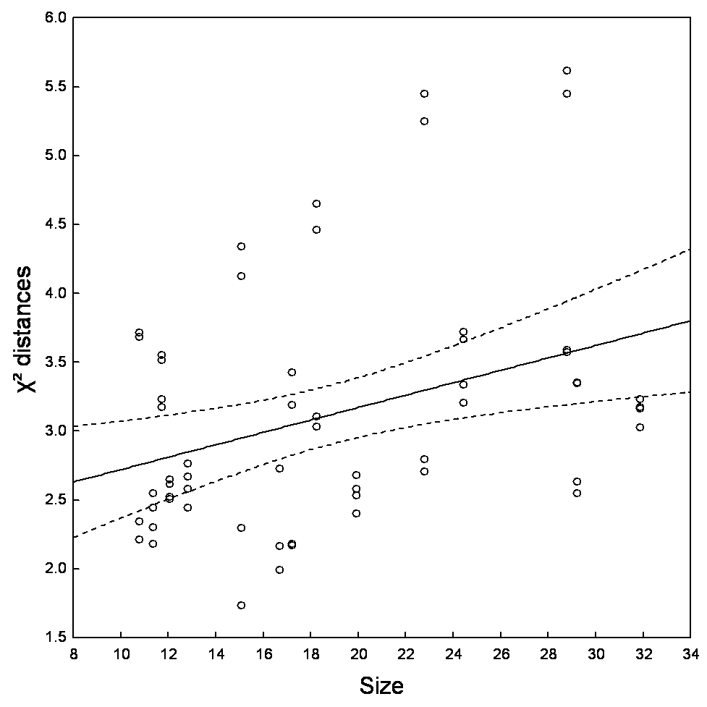
Figure 4: Linear regression of chi2 distances between butterfly assemblages of Nymphaloidae in pairs of gap and understory trap and gap size. Gap size square root of m² (y = 2.27 + 0.0451x; r = 0.3525, p = 0.0057; r² = 0.1242).

The second PCA, that considered only data from gaps, showed clear patterns of butterfly assemblages (Fig. 5). Many species seemed clearly associated with the environmental variables describing the vegetation structure of the gaps. The majority of the species were associated with the absence of vines, and the higher light levels in larger gaps (Fig. 5).
Only few species such as Taygetis angulosa, T. sosis, and T. laches, were associated with high vine density. Several species e.g. Nessea obrinius, was associated with small gaps, without low light, whereas Zaretis isidora, Adelpha jordani, and Memphis glauce, were associated with large gaps and higher amount of light.
Figure 5: PCA ordination diagram of butterfly communities (a) and environmental variables within 15 tree-fall gaps in Manu National Park, Peru. Only the 29 species that contribute most to the model are shown. Eigenvalues of PC1 (x axis) and PC2 (y axis) are 22.0 and 11.3

Discussion

Butterfly assemblages in gaps and understory
A clear difference was found in Nymphalidae assemblages between gaps and understory. From the 82 species captured, 39% were found only in gaps, while 13.4% were restricted to the understory. Similar results have been found in Bornean rainforests (Hill & Hamer, 2004; Hamer et al., 2003)) and in Ecuador (DeVries et al., 1999; DeVries & Walla, 2001). However, an almost equal amount of individuals were found in gaps and in the understory. Estimated number of species was also higher in the gaps (119.05) compared to understory (74.2). A potential bias is that the traps sampled only the ground level but as ripe fruits fall to the ground the majority of the fruit feeding species are likely to be found at that level (Hill et al., 2001).
The number of species increased quickly during the first sampling weeks, and leveled off as the areas were more completely sampled. However, the species accumulation curve did not reach an asymptote indicating that more species would have been found with an increased sampling period. Many species are seasonal (DeVries, 1999, 2001) and show a peak of abundance during a specific period only. For example, Panacea prola appeared first at week seven, and then was the predominant species in both habitats (52.34% in gaps and 68.86% in understory) from week 11 until the end of the study. Studies in Yasuni National Park, in Ecuadorian Amazonia over 13 months showed that composition and structure of butterfly assemblages varied significant during the survey with a constant replacement of species throughout the year (Checa et al., 2009).
The clear pattern observed on the distribution of the species between the gaps and understory indicated that species were associated with different habitats. According to the PCA and pRDA scores, the species Pyrrhogyra amphiro, Archeoprepona demophon, Morpho helenor, Adelpha iphiclus, and Memphis basiles showed the strongest association with gaps, whereas, Tigridia acesta, Nessea obrinius, Catoblepia berecynthia, Ca. xantus and Pseudobedis valentina show an association with the understory. The light level was also an important factor for the butterfly assemblages and was, as expected, higher in the gaps. The species associated with the gaps were also the ones that were favored of a high amount of light, unlike the species associated with the understory. However, although gaps, understory and light are shown to be important explanatory variables, the analyses show that there are also other factors driving the repartition of the species.

Comparison of butterfly assemblages among gaps
The importance of gap size for structuring butterfly assemblages were analyzed and a simple regression analysis comparing the similarity of the traps according to a gradient of gap size showed a significant positive correlation between increasing diversity between traps and the increase of gap size. The amount of light has been shown to be an important component of the structure of tropical forests, affecting butterfly assemblages (Sparrow et al., 1994). The amount of sunlight reaching the ground is also an important factor affecting plant growth (Terborgh, 1992), and might play an indirect effect also on the quality of butterfly host plants (Blau, 1980) and quantity of resources (Checa et al., 2009).The butterfly assemblages occurring in the small gaps were more similar to the understory assemblages than the ones found in the big gaps.
The results of the PCA comparing the gaps show that the distribution of the nymphalid species is affected by several environmental variables. The vegetation structure, in terms of density, diameter and height, affects the butterfly species, and most of them present a strong association with the presence of the woody plants in gaps, and an avoidance of the vines. There were higher light levels in gaps with a large amount of woody plants. The gaps that were most species rich were also the most open ones, and contained only a few vines. The vines are fast growing species, covering the gaps quickly, and give a much denser habitat than woody plants. The presence of woody plants in the gaps probably indicates a younger gap, with a possibility of more resources for the butterfly assemblages.
Different nymphalid species were associated with small or big, dense and shady or clear and sun exposed gaps. Among them, Pseudobedis valentina and Nessea obrinius were found in small shaded gaps, known as understory species strongly correlated with undisturbed areas (DeVries et al., 1997). Panacea prola were associated with the small and open gaps, the gap species Adelpha jordani, Memphis glauce, Yphthimoides poltys, Tamenis laothoe, Bia actorion, and Zaretis isidora, related to large and clear gaps, and only a few species of Taygetis, T.angulosa, T.laches and T.sosis, were found mainly in large and dense gaps, in accordance with their biological characteristics as understory species.

Importance of heterogeneity
A clear result from this study is the high level of heterogeneity encountered in the study area. Even between the traps placed in the understory, with lower variation in light and vegetation structure, large differences in butterfly assemblages were found. Similar large variation between traps only 50-100 m apart has been found in central Brazil (Pinheiro & Ortiz, 1992) and on Borneo (Hill et al., 2001). The variation in butterfly assemblages among the gap traps was even larger than in the understory, and shows the complexity of the rainforest, and gives an insight in the mechanisms behind the high diversity encountered in the Neotropics, and the higher species richness found in the gaps.
The vegetation in the rainforest is subject to regular natural disturbances, like tree falls opening up the canopy. If disturbances occur at an intermediate level, allowing climax and pioneer species to coexist in the same area, they might favor a higher biodiversity. The Intermediate Disturbances Hypothesis (Connell, 1978) is one of the theories explaining the maintenance of the high biodiversity in the neotropics, as already shown for the trees (Molino & Sabatier, 2001; Terborgh, 1992). The differences in intensity, duration, frequency, and extend of disturbances provide specific habitats (Shea et al., 2004), like gaps of different size, vegetation structure and composition, age, light level, resulting on a mosaic of different habitats among the rainforest. This patchy micro-successional habitat resulting from such disturbances affects the species in different ways and their responses are also specific and ensure a greater species richness.
We conclude that the heterogeneity within the rainforest is of major importance to maintain a high level of biodiversity among the butterfly assemblages. The presence of different habitats, following a gradient from an undisturbed understory to large newly formed open gaps, via other small dense or open gaps, is a necessary requirement for the coexistence of the species. The biodiversity of the tropical rainforest is maintained by the occurrence disturbances, and one example is the tree fall like the formation of gaps of different sizes resulting in different structure types of the vegetation. This creates a mosaic of specific habitats that favors different species. Taken as indicators, the nymphalids show a very species rich community, even in a small scale study and without any vertical stratification analysis, and we can then expect other species to follow the same pattern.

Acknowledgments
I would like to thanks my supervisors Karl-Olof Bergman, Per Milberg & Harald Beck for their everyday support & advices, and my examiner Anders Hargeby for his comments.
Research permit to work in Manu National Park was kindly granted by the Peruvian government Institute of Natural Resources (IRENA) and the administration of Manu National Park.
I am also very grateful to the staff of the Cocha Cashu station, especially Matias, Ines, Cecilia, Jacob, Sam, Fortunato, Patricia & Amy. Many thanks also to the LiU staff, particularly Karin Tonderski & Ingevald, and finally the Natural History Museum in Lima, including Gerardo Lamas.
Thanks also to the scientists who helped for the species identification, especially Dr. Jacqueline Miller, Patrick Blandin & André Victor Lucci Freitas.
Finally, for being who they are & for everything they did, a special thanks to my fellow students, dear friends & beloved family.

References
Beck, H., Gaines, M.S. ,Hines, J. E. and Nichols, J. D. (2004)Comparative dynamics of small mammal populations in treefall gaps and surrounding understorey within Amazonian rainforest, Oikos 106:27–38
Beck, H. (2002) Population dynamics and biodiversity of small mammals in treefall gaps within an Amazonian rainforest, PhD thesis,University of Miami, Miami, Florida
Beck, H. (2008) Tropical Ecology, in Sven Erik Jørgensen and Brian D. Fath (Editor-in-Chief), General Ecology, Vol. [5] of Encyclopedia of Ecology, 5 vols. pp. [3616-3624] Oxford: Elsevier
Blau, W.S. (1980) The effect of environmental disturbance on a tropical butterfly population, Ecology 61:1005-1012
Brokaw, N.V.L. (1982) Treefalls: frequency, timing, and consequences, pp. 101–108, in Leigh, E. G., Rand, A. S. & Windsor,D. M. (eds.), The ecology of a tropical rainforest, Seasonal rhythms and long-term changes, Smithsonian Institute, Washington, DC
Chazdon, R.L., Pearcy, R.W., Lee, D.W. et al. (1996) Photosynthetic response of tropical forest plants to contrasting light environments, in: Mulkey, S.S., Chazdon, R.L. and Smith, A.P. (eds), Tropical forest plant ecophysiology, Chapman & Hall, pp. 1-55
Checa, M.F., Barragan, A., Rodriguez, J. & Christman, M. (2009) Temporal abundance patterns of butterfly communities (Lepidoptera: Nymphalidae), in the Ecuadorian Amazonia and their relationship with climate, Ann. soc. entomol. Fr., 45 (4): 470-486
Colwell R.K., Coddington J.A. (1994) Estimating terrestrial biodiversity through extrapolation, p. 101-118 in: Hawksworth D.L. (ed.), Biodiversity: measurement and estimation, Chapman & Hall Publications, London, UK
Connell, J.H. (1978) Diversity in Tropical Rain Forests and Coral Reefs, Science, Vol.199, No.4335, pp.1302-1310
Denslow, J.S., Moermond, T.C. and Levey, D.J. (1986) Spatial components of fruit display in understory trees and shrubs, in: Estrada, A. and Fleming, T.H. (eds), Frugivores and seed dispersal. W, Junk Publisher, pp. 37-44
Denslow, J.S. (1987) Tropical rainforest gaps and tree species diversity, Annual Review of Ecology and Systematics 18:431–451
DeVries, P.J. (1987) The butterflies of Costa Rica and their natural history, vol 1. Papilionidae, Pieridae and Nymphalidae, Princeton University Press, Princeton
DeVries, P.J. (1988) Stratification of fruit-feeding nymphalid butterflies in a Costa Rican rainforest, J Res Lepid 26, pp. 98-108
DeVries, P.J., Murray, D., Lande, R. (1997) Species diversity in vertical, horizontal, and temporal dimensions of a fruit-feeding butterfly community in an Ecuadorian rainforest, Biol J Linn Soc 62, pp.343-364
DeVries, P.J., Walla, T.R., Greeney, H.F. (1999) Species diversity in spatial and temporal dimensions of fruit-feeding butterflies from two Ecuadorian rainforests, Biol J Linn Soc 68, pp.333-353
DeVries, P.J. and Walla, T.R., (2001) Species diversity in spatial and temporal dimensions of fruit-feeding butterflies from two Ecuadorian rainforests, Biol J Linn Soc 74, pp. 1-15
Fermon, H., Waltert, M., Larsen, T.B., Dall’Asta, U. and Mühlenberg M. (2000) Effects of forest management on diversity and abundance of fruit-feeding nymphalid butterflies in south-eastern Côte d’Ivoire, Journal of Insect Conservation 4, pp. 173-189
Fermon, H., Waltert, M., Vane-Wright, R.I., Muhlenberg, M. (2005) Forest use and vertical stratification in fruit-feeding butterflies of Sulawesi, Indonesia: impacts for conservation, Biodiversity and Conservation 14, issue 2, pp. 333-350
Hamer, K.C., Hill, J.K., Lace, L.A., Langan, A.M. (1997) Ecological and biogeographical effects of forest disturbance on tropical butterflies of Sumba, Indonesia, J Biogeo. 24, pp. 67-75
Hamer K.C., Hill J.K., Benedick S., Mustaffa N., Sherratt T.N., Maryatis M., Chey V.K. (2003) Ecology of butterfl ies in natural and selectively logged forests of northern Borneo: the importance of habitat heterogeneity, The Journal of Applied Ecology 40: 150-162
Hamer, K.C., Hill, J.K., Benedick, S., Mustaffa, N., Chey, V.K. & Mohamed, M. (2006) Diversity and ecology of carrion and fruit-feeding butterflies in Bornean rainforest, Journal of Tropical Ecology 22, 25-33
Hill, J.K., Hamer, K.C., Tangah, J. and Dawood, M. (2001) Ecology of tropical butterflies in rainforest gaps, Oecologia 128, pp. 294-302
Hill, J.K., Hamer, K.C., (2004) Determining impacts of habitat modification on diversity of tropical forest fauna: the importance of spatial scale. Journal of Applied Ecology 41, 744–754
Hubbell, S.P., Foster, R.B., O’Brien, S.T., Harms, K.E., Condit, R., Wechsler, B., Wright, S.J. & Loo Delao, S. (1999) Light gap disturbances, recruitment limitation, and tree diversity in a Neotropical forest, Science 283:554–557
Kremen C. (1992) Assessing the indicator properties of species assemblages for natural areas monitoring, Ecological Applications 2: 203-217
Lamas, G: (1997) Comparing the butterfly faunas of Pakitza and Tambopata, Madre de Dios, Peru, or why is Peru such a mega-diverse country?, H.Ulrich (ed), Tropical biodiversity and systematics, pp. 165-168
Lamas, G. (2004) Atlas of Neotropical Lepidoptera, Checklist: Part 4A, Hesperioidea-Papilionoidea, Scientific Publishers, Florida, USA, 439 p.
Leigh, E.G., Davidar, P., Dick, C.W., Puyravaud, J.P., Terborgh, J., ter Steege, H. & Wright, S.J. (2004) Why do some tropical forests have so many species of trees?, BIOTROPICA 36 : 447-473
Levey, D.J. (1988) Tropical wet forest treefall gaps and distributions of understory birds and plants. Ecology 69:1076–1089
Levey, D.J. (1990) Habitat depending fruiting behavior of an understory tree, Miconia centrodesma, and tropical treefall gaps as keystone habitats for frugivores in Costa Rica, J. Trop. Ecol. 6: 409-420
Molino, J.F. & Sabatier, D. (2001) Tree diversity in tropical rain forests: a validation of the intermediate disturbance hypothesis, Science 294: 1702–1704.
Murray, D.L. (2000) A Survey of the Butterfly Fauna of Jatun Sacha, Ecuador (Lepidoptera: Hesperioidea and Papilionoidea), Journal of Research on the Lepidoptera 35, pp. 42-60
Olson, D. M. and Dinerstein, E. (2002) The Global 200: Priority Ecoregions for Global Conservation, Annals of the Missouri Botanical Garden, Vol. 89, No. 2 pp. 199-224
Pinheiro C.E., Ortiz J.V. (1992) Communities of fruit-feeding butterflies along a vegetation gradient in central Brazil, Journal of Biogeography 19: 505-511
Schnitzer, S.A., & Bongers, F. (2002) The ecology of lianas and their role in forests, Trends in Ecology and Evolution 17, 223–230
Shahabuddin, G. and Terborgh, J.W. (1999) Frugivorous butterflies in Venezuelan forest fragments: abundance, diversity and the effects of isolation, J Trop. Ecol. 15, pp. 703-722
Shea, K., Roxburgh, S.H., Rauschert, E.S.J. (2004) Moving from pattern to process: coexistence mechanisms under intermediate disturbance regimes, Ecology Letters 7: 491-508
Sparrow, H., Sisk T., Ehrlich P., Murphy D. (1994) Techniques and guidelines for monitoring neotropical butterflies. Conservation Biology 8: 800-809.
Spitzer, K., Jaros, J., Havelka, J., Leps, J. (1997) Effect of small-scale disturbance on butterfly communities of an Indochinese montane rainforest, Conservation Biology 80, pp. 9-15
Sutherland, W.J. (2006) Ecological Census Techniques: a handbook, Cambridge University Press, Cambridge
Tangah, J., Hill, J.K., Hamer, K.C. and Dawood, M.M. (2004) Vertical distribution of fruit-feeding butterflies in Sabah, Borneo, Sepilok Bulletin 1, pp. 17-27
ter Braak, C.J.F., & Smilauer, P. (2002) Canoco 4 Microcomputer power, Ithaca, NY, USA
Terborgh, J. (1990) An overview of research at Cocha Cashu Biological Station, pp. 48-59, in A. H. Gentry, editor, Four Neotropical forests, Yale University Press, New Haven, Connecticut, USA
Terborgh, J. (1992) Diversity and the tropical rain forest, Scientific American Library, New York
Tomlinson, P.S. (1991) Structural Elements of the rain forest, in Ecosystems of the world, vol 14A, Tropical rain forest ecosystems: Structure and function, Golley F.B. (ed.), Elsevier Science Publishing Company, Amsterdam
Waide, R.B. (2008) Tropical Rainforest, in Sven Erik Jørgensen and Brian D. Fath (Editor-in-Chief), General Ecology, Vol. [5] of Encyclopedia of Ecology, 5 vols. pp. [3625-3629] Oxford: Elsevier Ecosystems

